1. **Identify the problem**

Initially, cake is actually a bread- like shape and taste but sweetened with honey during the ancient time. Nevertheless, due to the Industrial Revolution in middle of 19th century, the cake is made of a mixture of flour, egg, sugar, butter or oil, baking soda, vanilla extract and other additional ingredients to make it delicious. The word ‘cake’ is derivative from Old Norse’s word located at Viking origin, called ‘kaka’. At Greek period, cakes are known as ‘plakous’ derived from word ‘plakoeis’ which mean flat, meanwhile in ancient Roman, they called cake as ‘placenta’ which was derived from the Greek term. Surprisingly, ancient Egyptian is the first culture that prove their improvement in baking skill according to the food historian.

In ancient history, cake often made to serves the god and spirits at particular time on culture’s ritual ceremony every year. For instance, during the harvest time, Chinese made cakes to honour their moon deity because they believe the moon hold an important task in seasonal cycle. Thus, they made a round-shape cake to imitate the moon shape to reward their goddess. Similarly, the action also performed by the ancient Celt, however they made cake called Beltane cake during Beltane festival on the first day of spring. Unlike Chinese, ancient Celt baked cakes which resemble the sun’s shape and rolled it down a hill to emulate the movement of sun. They wish by executing this action, the sun will always continue to move.

Nevertheless, in this modern era, cake is frequently found at wedding ceremony, birthday party and Christmas occasion. At wedding ceremony, cake is crucial because it related to some of the culture activities that have its own meaning. For example, the action of cake cutting indicate the first activity done as a couple, even though historically the bride did this action alone to symbolize the loss of her virginity. And the meaning behind the groom and the bride feeding one other is to symbolize the love between them and the commitment that will be provided by each other. Furthermore, in birthday party, cake paired with the lit candle because they believe when they pray and blow the candle, the smoke will carry their prayers to the gods in the heavens.

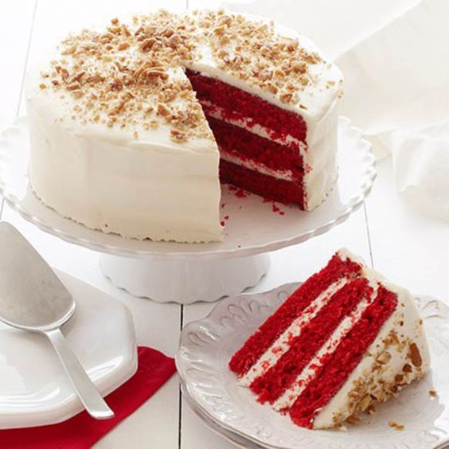There are variety of cakes out there starting with layer cake, butter cake, sponge cake, cupcake and flourless chocolate cake. All of these cakes are available in many different flavours that give an opportunity for each person to choose their favourite flavour.

Layer cake is a type of cake that contain multiple layers of butter cake or sponge cake 1 inch to 2 inch height being separate by cream, frosting or other filling. Red velvet cake, black forest cake, chocolate cake and carrot cake filled with cream cheese are among the famous cakes that commonly served at wedding ceremony.

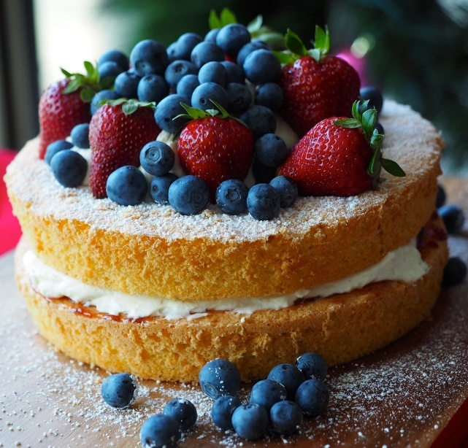

Sponge cake or foam cake is made from flour, egg white, sugar and baking powder. This cake does not have any fat in it since the ingredients have no fat. Normally, people will beat the white egg with sugar and slowly add the flour inside the mixture until it expands. Sponge cake might not have different flavour, but usually people would decorate it with icing and fruits on top of it.

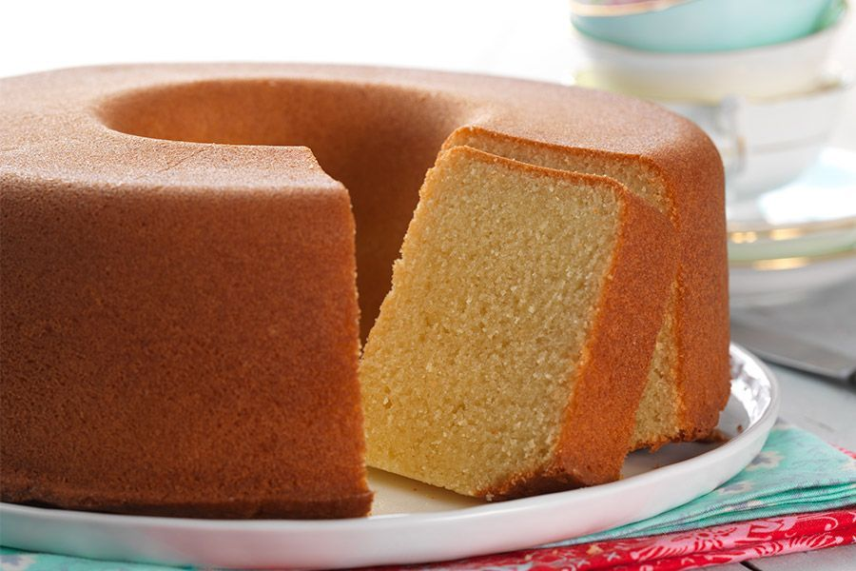

Butter cake clearly consist of butter as the main ingredient. Just like sponge cake, butter cake also needs to be whip. It starts with the mixing of sugar and butter followed by adding eggs one at a time. Uniquely, this type of cake is moist and luscious if it is kept at room temperature and become dry out plus lose flavour when we store it in fridge.

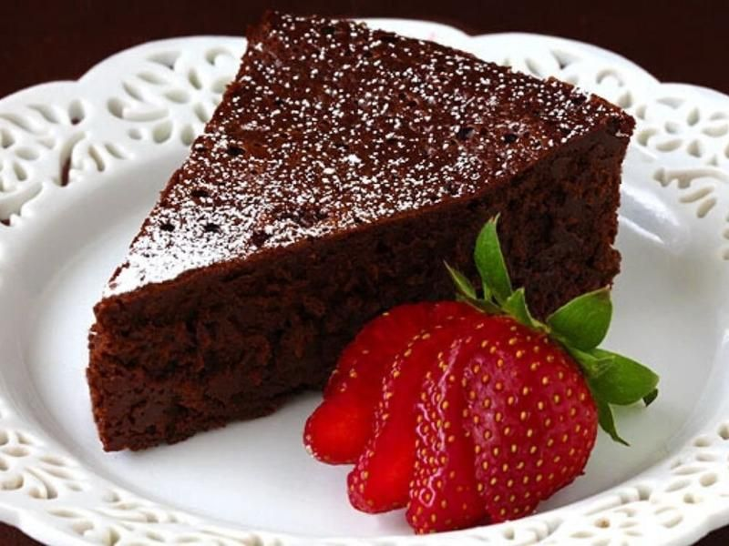

Flourless chocolate cake is made of butter, eggs, sugar, cocoa powder, vanilla, salt, and an optional dusting of powdered sugar. It starts with whip the white egg until it expands then whip the yolk with sugar. Then, put the additional ingredient inside it. This cake does not contain flour at all. However, its texture is light because the action of whipping the egg can increase the air content inside it.

In this era, many cake shops are built to serve the people with their wanted cake since there are various type of cakes nowadays. Nevertheless, the increasing in waste, has made plenty of the cake shops realize the important of clean environment. Waste are materials that have be thrown away when it became worthless. There are four type of waste which are municipal waste includes household waste, commercial waste, and demolition waste, hazardous waste includes industrial waste, biomedical waste includes clinical waste, special hazardous waste includes radioactive waste, explosive waste, and electronic waste (e-waste).

Special Cake is one of the cake shops in Malaysia that show concern about this problem and they know that if no one in this country take action, then our country will face a big trouble in the future because the number of wastes will become higher. Thus, they think they need to take an approach by spreading awareness to people about this waste’s problem. Therefore, people exposed to this issue and hopefully the amount of waste material will reduce.

However, they do not know how to disseminate the awareness since they have to consider many challenges such as the decrement of their profit and the chance of this campaign to success is unknown.

**2. Understand the problem**

Special Cake is a cake shop located at Sintok, Kedah. They are one of the shops in Malaysia that worry about the growth of waste material in this country. Hence, they want to educate the people about the significant of unpolluted environment. This aim of this method is to reduce the number of wastes in this country.

But, as a shop, Special Cake need to consider about the profit of sales and best method to educate the folks about waste and how to overcome it. Without a proper knowledge to solve this problem, Special Cake may suffer a loss in business. Its need to find a finest solution that can gain its profit and at the same time success in encouraging the people to decrease the waste in their daily routine.

**3. Identify alternative ways to solve the problem**

1. Special Cake’s team must use an environmentally friendly materials to pack their foods such as cupboard, bagasse paper, and aluminium. This is because environmentally friendly materials are easy to recycle and decompose.
2. Special Cake’s team may write a short message to spread the fundamental knowledge about the important of waste reduction on receipt.
3. The baker can reduce the food waste while making the cake by practicing accurate measurement and baking skills.
4. The owner of Special Cake can provide discount on National Recycling Day (11 November) and Global Recycling Day (18 March) every year.
5. The baker can plan enough amounts of cupcakes to bake in a day to prevent food waste.
6. At the front door of the shop, a Special Cake’s member can paste a poster about the facts of waste in this world, thus the customer will have a chance to read it.
7. Special Cake’s team need to implement a recycling habit while working, as a consequence, customer affected to follow the habit.
8. Special Cake’s team need to design a new decoration based on the waste disposal theme that include the tips to recycle on their packaging materials.
9. Special Cake’s team can create a contest to encourage their customer to apply the recycle habit in their life. And as a reward for their participation, Special Cake’s team can give 5% off in their purchase.
10. Special Cake’s team should hold a No Plastic Bag Day every one a week to prevent more waste on plastic bag.
11. Special Cake’s team can provide recycle bins outside their shop to attract people attention and develop their interest to start recycle.

**4. Select the best way to solve the problem from the list of alternative solutions.**

The best way to deal with this problem is Special Cake’s team must use an environmentally friendly materials to pack their product such as paper bag, container and friendly bag.

**5. List instructions (steps) that enable you to solve the problem using the selected solution**.

1. The program will greet the user by saying “Hi! Welcome to Special Cake!!!”.
2. Then, program will jump to ‘menuToChoos()’ method.
3. Inside ‘menuToChoos()’ method, user need to choose one of the services provided by key in whether number 1 or number 2 or number 3. Number 1 is Special Choose, number 2 is Special Slice and number 3 for Special Cupcake. They only may enter these 3 numbers. If user input other number except from these numbers, program will print ‘Invalid. Choose again’. User must enter correct number to go for the next instruction. Tables below show the detail about the menu.
4. Menu of Special Choose –

This menu particularly for customer that want to choose a cake for their birthday party, wedding ceremony or just for a casual event. Customers can see the detail of the cakes including it weight, height and size. There are 3 types of techniques used to make the cake whether bake or steam or mixed with ice cream (known as ice cream cake). Customer also will see the price for each cake.

At some part like size of cake, height of cake, type of cake and name of cake customer need to input the code of the cake. This action is used to make sure customer feel easy when using this program.

|  |  |  |  |  |  |
| --- | --- | --- | --- | --- | --- |
| **Size (inch) [code]** | **Weight (kg)** | **Height**  **(inch)**  **[code]** | **Type [code]** | **Name**  **[code]** | **Price (RM)** |
|  |  |  |  | Tiramisu/9 | 94 |
|  |  |  |  | New York Cheese Cake/10 | 100 |
|  |  |  | Bake/40 | Black Forest/11 | 106 |
|  |  |  |  | Caramel Cream/7 | 82 |
|  |  |  |  | Oreo Cake/8 | 88 |
|  |  |  |  | Old Fashion Chocolate Cake/12 | 112 |
| 6 | 0.7 | 5 |  | Tiramisu | 96 |
|  |  |  |  | New York Cheese Cake | 102 |
|  |  |  | Steam/42 | Black Forest | 108 |
|  |  |  |  | Caramel Cream | 84 |
|  |  |  |  | Oreo Cake | 90 |
|  |  |  |  | Old Fashion Chocolate Cake | 114 |
|  |  |  |  | Tiramisu | 114 |
|  |  |  |  | New York Cheese Cake | 120 |
|  |  |  | Ice cream/ | Black Forest | 126 |
|  |  |  | 60 | Caramel Cream | 104 |
|  |  |  |  | Oreo Cake | 108 |
|  |  |  |  | Old Fashion Chocolate Cake | 132 |
|  |  |  |  | Tiramisu | 112 |
|  |  |  |  | New York Cheese Cake | 120 |
|  |  |  | Bake | Black Forest | 128 |
|  |  |  |  | Caramel Cream | 96 |
|  |  |  |  | Oreo Cake | 104 |
|  |  |  |  | Old Fashion Chocolate Cake | 136 |
| 8 | 1.3 | 5 |  | Tiramisu | 114 |
|  |  |  |  | New York Cheese Cake | 122 |
|  |  |  | Steam | Black Forest | 130 |
|  |  |  |  | Caramel Cream | 98 |
|  |  |  |  | Oreo Cake | 106 |
|  |  |  |  | Old Fashion Chocolate Cake | 138 |
|  |  |  |  | Tiramisu | 132 |
|  |  |  |  | New York Cheese Cake | 140 |
|  |  |  | Ice cream | Black Forest | 148 |
|  |  |  |  | Caramel Cream | 116 |
|  |  |  |  | Oreo Cake | 124 |
|  |  |  |  | Old Fashion Chocolate Cake | 136 |

1. Menu of Special Cupcake –

There are 2 size available for cupcake which are 2 inch and 2.5 inch. All the detail are shown in the table below.

|  |  |  |  |  |  |
| --- | --- | --- | --- | --- | --- |
| **Size (inch)** | **Weight**  **(kg)** | **Height**  **(inch)** | **Type**  **[code]** | **Name**  **[code]** | **Price (RM)** |
|  |  |  |  | Banana [1.5] | 4 |
|  |  |  | Bake [1] | Carrot [2.5] | 6 |
|  |  |  |  | Chocolate [1] | 3 |
|  |  |  |  | Vanilla [0.5] | 2 |
|  |  |  |  | Banana [1.5] | 4.5 |
|  |  |  | Steam [1.5] | Carrot [2.5] | 6.5 |
| 2 [2] | 0.08 | 1.5 |  | Chocolate [1] | 3.5 |
|  |  |  |  | Vanilla [0.5] | 2.5 |
|  |  |  |  | Banana [1.5] | 5 |
|  |  |  | Ice cream [1] | Carrot [2.5] | 7 |
|  |  |  |  | Chocolate [1] | 4 |
|  |  |  |  | Vanilla [0.5] | 3 |
|  |  |  |  | Banana [1.5] | 4.75 |
|  |  |  | Bake [1] | Carrot [2.5] | 7.25 |
|  |  |  |  | Chocolate [1] | 3.5 |
|  |  |  |  | Vanilla [0.5] | 2.25 |
|  |  |  |  | Banana [1.5] | 5.25 |
|  |  |  | Steam [1.5] | Carrot [2.5] | 7.75 |
| 2 .5 [2.5] | 0.08 | 1.5 |  | Chocolate [1] | 4 |
|  |  |  |  | Vanilla [0.5] | 2.75 |
|  |  |  |  | Banana [1.5] | 5.75 |
|  |  |  | Ice cream [1] | Carrot [2.5] | 8.25 |
|  |  |  |  | Chocolate [1] | 4.5 |
|  |  |  |  | Vanilla [0.5] | 3.25 |

1. Menu of Special Slice –

For slice of cake, customer have limited options. They only can choose the name of cake that they want. But, they still need to input the data of the cake such as size of cake and type of cake that they want.

|  |  |  |  |  |  |
| --- | --- | --- | --- | --- | --- |
| **Size**  **[code]** | **Shape** | **Height**  **(inch)** | **Type [code]** | **Name**  **[code]** | **Price (RM)** |
|  |  |  |  | Burnt Cheese Cake | 10 |
|  |  |  |  | Red Velvet | 10 |
| 2 [2] | Triangle | 5 | Baked [10] | Rainbow | 10 |
|  |  |  |  | Creamy Vanilla Fruit Cake | 10 |
|  |  |  |  | Chocolate Truffle Cream Cake | 10 |
|  |  |  |  | Classic Almond Cake | 10 |

1. After chose the service, program will bring user to the desired method of that category. In each method, user must fill in their information detail about

* Customer’s name
* Contact number
* User address

1. Next, the program ask user to input information such as:

* Date of order
* Month of order
* Date to receive the cake
* Month to receive the cake

1. Before moving further, the program will check whether the date fulfilled the condition or not. If the date exceeds or same with 7 days, the program will show the detail about the menu of that category. If not, it will ask user to input the date until it corrects.
2. After looking at the menu given, customer should answer the given question by entering the right code. At the questions statement, program will specified the code for each answer. Thus, user would not get confused to answer the questions. The 4 questions that will be asked are:

* Size of the cake
* Name of the cake
* Type of the cake
* Amount of cake

8. Later, the program automatically print out the packaging menu for that chosen category. Similar at step 7, user once again need to answer 2 questions which are about:

* Size of the packaging
* Material for packaging

The menu based on categorys are as shown below:

A. Menu of Special Choose’ Packaging Materials –

Customer can choose cake stand or cake board as a packaging material. But customers are recommended to bring our-branded cake stand or cake board that they had bought before. They may choose material that they want to store the cake.

|  |  |  |  |  |
| --- | --- | --- | --- | --- |
| **Type** | **Height(inch)/ Shape** | **Decoration colour/Colour** | **Material** | **Price (RM)** |
|  |  |  | Glass | 184 |
|  |  |  | Clay | 140 |
|  |  | White | Wood | 44 |
|  |  |  | Aluminium | 28 |
|  |  |  | Glass | 184 |
|  |  |  | Clay | 140 |
|  | 4 | Silver | Wood | 44 |
|  |  |  | Aluminium | 28 |
|  |  |  | Glass | 184 |
|  |  |  | Clay | 140 |
|  |  | Gold | Wood | 44 |
| Cake Stand |  |  | Aluminium | 28 |
|  |  |  | Glass | 230 |
|  |  |  | Clay | 175 |
|  |  | White | Wood | 55 |
|  |  |  | Aluminium | 35 |
|  |  |  | Glass | 230 |
|  |  |  | Clay | 175 |
|  | 5 | Silver | Wood | 55 |
|  |  |  | Aluminium | 35 |
|  |  |  | Glass | 230 |
|  |  |  | Clay | 175 |
|  |  | Gold | Wood | 55 |
|  |  |  | Aluminium | 35 |
|  |  |  | Glass | 46 |
|  |  |  | Clay | 35 |
|  |  | White | Wood | 11 |
|  |  |  | Aluminium | 7 |
|  |  |  | Glass | 46 |
|  | Square/ |  | Clay | 35 |
| Cake Bound | Rectangle/ | Silver | Wood | 11 |
|  | Round |  | Aluminium | 7 |
|  |  |  | Glass | 46 |
|  |  |  | Clay | 35 |
|  |  | Gold | Wood | 11 |
|  |  |  | Aluminium | 7 |
| User Cake Stand/Board |  | from our-branded shop only |  | 0 |

B. Menu of Special Cupcake Packaging’s Material –

|  |  |  |  |
| --- | --- | --- | --- |
| **Type** | **Height [code]** | **Material [code]** | **Price (RM)** |
|  |  | Aluminium Foil [2] | 2 |
| a box of 6 | 3[1] | Bagasse Paper [3] | 3 |
| cupcakes |  | Shop's Container [8] | 8 |
|  |  | Customer's container [0] | 0 |

C. Menu of Special Slice Packaging’s Material–

|  |  |  |  |
| --- | --- | --- | --- |
| **Type** | **Height [code]** | **Material [code]** | **Price (RM)** |
|  |  | Aluminium Foil [0.7] | 1.4 |
| a box of 2 slice | 6[2] | Bagasse Paper [0.5] | 1 |
|  |  | Shop's Container [2] | 4 |
|  |  | Customer's container [0] | 0 |

1. Then, the program will do calculation based on

* Price of one cake chosen by the customer
* Total price of cake
* Price of packaging chosen by the customer
* Total price to pay
* Discount received
* Total price to pay

10. Lastly, the program will print receipt for user including some information like:

* Customer’s name
* Date to pick up the order
* Code for cake’s size
* Code for cake
* Code for type of cake
* Quantity of cake
* Type of packaging
* Code for packaging size
* Code for packaging material
* Subtotal
* Discount received
* Total payment

**6. Evaluate the solution.**

This is because they can use finest materials to pack the cake. So, they can charge extra price to customer because the material used to make their packaging container is quite expensive. By doing this, the Special Cake can increase their sale.

For some customer that enable to accept the price provide by the cake shop, they are encourage to bring their own container to pack the food. This method obviously can save the customer’s money and without any hesitation, the Special Cake successfully attract people concern to reduce their daily waste.

**7. Algorithm**

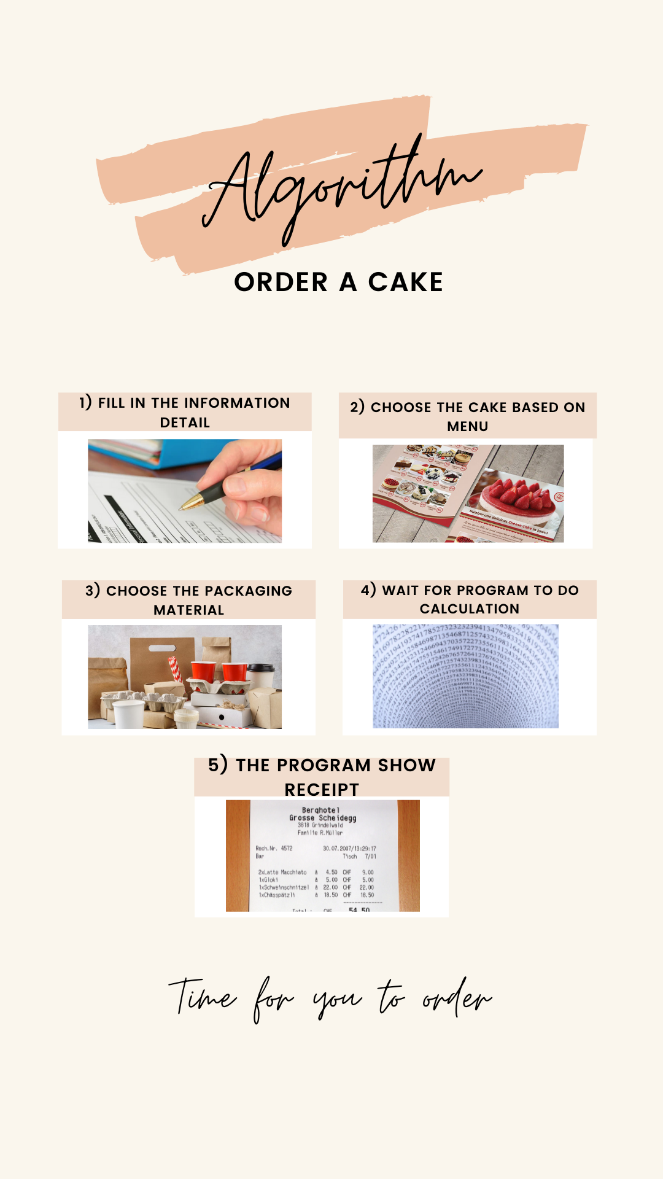

1. **Pseudocode**

Start

Print “Hi! Welcome to Special Cake”

methodToChoose();

Print “The services we offer are:”

Print “1. Special Choose \n\t 2. Special Slice 3. Special Cupcake

Input ans_service

If (ans_servise same with 1)

categoryOne()

Else if ( ans_service same with 2)

categoryTwo()

Else if ( ans_service same with 3)

categoryThree()

Else

categoryFour()

End if

End

// categoryOne();

Start

Print “Please fill the information detail”

name = ansName("")

contact = ansContact(y)

address = ansAddress("")

pickUp = dateDetail(e, f, g, h)

Print “#############################################”

Print “Category 1: Special Choose”

Print “#############################################”

Print “Size(inch) [code] Weight (kg) Height(inch) Type [code] Name [code] Price (RM)”

Print “Tiramisu [9] 94");

Print “New York Cheese Cake [10] 100");

Print “Baked [40] Black Forest [11] 106");

Print “Caramel Cream [7] 82”

Print “Oreo Cake [8] 88”

Print “Old Fashion Chocolate Cake [12] 112”

Print “Tiramisu [9] 96");

Print “New York Cheese Cake [10] 102”

Print “6 [6] 0.7 5 Steam [42] Black Forest [11] 108”

Print “Caramel Cream [7] 84");

Print “Oreo Cake [8] 90");

Print “Old Fashion Chocolate Cake [12] 114");

Print “Tiramisu [9 114");

Print “New York Cheese Cake [10] 120”

Print “Ice cream [60] Black Forest [11] 126”

Print “Caramel Cream [7] \t\t 104”

Print “Oreo Cake [8] \t\t\t 108”

Print “Old Fashion Chocolate Cake [12] 132”

Print “#############################################”

Print “Tiramisu [9] 112”

Print “New York Cheese Cake [10] 120”

Print “Baked [40] Black Forest [11] 128”

Print “Caramel Cream [7] \t\t 96");

Print “Oreo Cake [8] 104”

Print “Old Fashion Chocolate Cake [12] 136”

Print “Tiramisu [9] 114”

Print “New York Cheese Cake [10] 122”

Print “8[8] 1.3 5 Steam [42] Black Forest [11] 130”

Print “Caramel Cream [7] 98”

Print “Oreo Cake [8] 106”

Print “Old Fashion Chocolate Cake [12] 138”

Print “Tiramisu [9] 132”

Print “New York Cheese Cake [10] 140”

Print “Ice cream [60] Black Forest [11] 148”

Print “Caramel Cream [7] 116”

Print “Oreo Cake [8] 124”

Print “Old Fashion Chocolate Cake [12] 136”

Print “#############################################”

Q1Array(sA)

ans_size1 = sizeCake(i)

Q2Array(nA)

ans_code1 = codeCake(j)

Q3Array(tA)

ans_type1 = typeCake(k)

Q4Array(noA)

ans_no1 = numberOfCake(l)

packCategoryOne();

Print “For the questions below, Please state the CODE :”

Q1Array4(hA)

sizePackaging(m)

Q2Array4(mA)

materialPackaging(n)

price_one_cake = (ans_size1 * ans_code1)+ ans_type1

to_price = (ans_no1*price_one_cake)

price_pack = (size_pack*mater_pack)* ans_no1

sum_all = price_pack+ to_price

dis_rec = (0.05*sum_all)

pay = (sum_all - dis_rec)

Print “NAME: " + name)”

Print “DATE OF ORDER: " + order)”

Print “DATE TO PICK UP: " + take)”

Print “DETAILS”

Print “CODE FOR SIZE OF CAKE: " + ans_size1”

Print “CODE FOR CAKE: " + ans_code1”

Print “CODE FOR TYPE OF CAKE: " + ans_type1”

Print “QUANTITY OF CAKE: " + ans_no1”

Print “TYPE OF PACKAGING: " + type_pack”

Print “CODE FOR PACKAGING SIZE: "+ size_pack”

Print “CODE FOR PACKAGING MATERIAL: " + mater_pack)”

Print “SUBTOTAL: " +sum_all”

Print “DISCOUNT RECEIVE: %.1f" ,dis_rec”

Print “TOTAL PAYMENT: %.1f", pay”

Print “*Please bring your container”

Print “3 days before date of pick”

Print “Thank you for purchase from us*”

Print “#############################################”

End

// categoryTwo()

Start

Print “Please fill the information detail”

name = ansName("")

contact = ansContact(y)

address = ansAddress("")

pickUp = dateDetail(e, f, g, h)

Print “#############################################”

Print “Category 2: Special Cupcakes”

Print “#############################################”

Print “Size(inch) [code] Weight (kg) Height(inch) Type [code] Name [code] Price (RM)”

Print “Banana [1.5] 4”

Print “Carrot [2.5] 6”

Print “Baked [1] Chocolate [1.0] 3”

Print “Vanilla [0.5] 2”

Print “Banana [1.5] 4.5");

Print “Carrot [2.5] 6.5”

Print “2.0 [2] 0.08 1.5 Steam [1.5] Chocolate [1.0] 3.5”

Print “Vanilla [0.5] 2.5”

Print “Banana [1.5] 5”

Print “Carrot [2.5] 7”

Print “Ice cream [1] Chocolate [1.0] 4”

Print “Vanilla [0.5] 3”

Print “#############################################”

Print “Banana [1.5] 4.75”

Print “Carrot [2.5] 7.25”

Print “Baked [1] Chocolate [1.0] 3.5”

Print “Vanilla [0.5] 2.25”

Print “Banana [1.5] 5.25”

Print “Carrot [2.5] 7.75”

Print “2.5[ 2.5] 0.08 1.5 Steam [1.5] Chocolate [1.0] 4”

Print “Vanilla [0.5] 2.75”

Print “Banana [1.5] 5.75”

Print “Carrot [2.5] 8.25”

Print “Ice cream [1] Chocolate [1.0] 4.5”

Print “Vanilla [0.5] 3.25”

Print “#############################################”

Print “#############################################”

Print “For the questions below, Please state the CODE :”

Q1Array(sA)

ans_size1 = sizeCake(i)

Q2Array(nA)

ans_code1 = codeCake(j)

Q3Array(tA)

ans_type1 = typeCake(k)

Q4Array(noA)

ans_no1 = numberOfCake(l)

packCategoryTwo();

Q1Array5(hA)

size_pack = sizePackaging(m)

Q2Array5(mA)

mater_pack = materialPackaging(n)

price_one_cake = (ans_size1 * ans_code1)+ ans_type1

to_price = (ans_no1*price_one_cake)

price_pack = (size_pack*mater_pack)* ans_no1

sum_all = price_pack+ to_price

dis_rec = (0.05*sum_all)

pay = (sum_all - dis_rec)

Print “NAME: " + name)”

Print “DATE OF ORDER: " + order)”

Print “DATE TO PICK UP: " + take)”

Print “DETAILS”

Print “CODE FOR SIZE OF CAKE: " + ans_size1”

Print “CODE FOR CAKE: " + ans_code1”

Print “CODE FOR TYPE OF CAKE: " + ans_type1”

Print “QUANTITY OF CAKE: " + ans_no1”

Print “TYPE OF PACKAGING: " + type_pack”

Print “CODE FOR PACKAGING SIZE: "+ size_pack”

Print “CODE FOR PACKAGING MATERIAL: " + mater_pack)”

Print “SUBTOTAL: " +sum_all”

Print “DISCOUNT RECEIVE: %.1f" ,dis_rec”

Print “TOTAL PAYMENT: %.1f", pay”

Print “*Please bring your container”

Print “3 days before date of pick”

Print “Thank you for purchase from us*”

Print “#############################################”

End

// categoryThree()

Start

Print “Please fill the information detail”

name = ansName("")

contact = ansContact(y)

address = ansAddress("")

pickUp = dateDetail(e, f, g, h)

Print “#############################################”

Print “Category 3: Special Slice”

Print “#############################################”

Print “Size(inch) [code] Shape (kg) Height(inch) Type [code] Name [code] Price (RM)”

Print “Burnt Cheese [3] \t\t 10”

Print “Red velvet [4] 10”

Print “Triangular 5 Baked [10] Rainbow [15] 10”

Print “Creamy Vanilla Fruit Cake [6] 10”

Print “Chocolate Truffle Cream Cake [13] 10”

Print “Classic Almond Cake [14] 10”

Print “#############################################”

Print “#########################################”

Q1Array3(sA)

ans_size1 = sizeCake(i)

Q2Array3(nA)

ans_code1 = codeCake(j)

Q3Array3(tA)

ans_type1 = typeCake(k)

Q4Array(noA)

ans_no1 = numberOfCake(l)

packCategoryThree();

Print “For the questions below, Please state the CODE :”

Q1Array6(hA)

sizePackaging(m)

Q2Array6(mA)

materialPackaging(n)

price_one_cake = (ans_size1 * ans_code1)+ ans_type1

to_price = (ans_no1*price_one_cake)

price_pack = (size_pack*mater_pack)* ans_no1

sum_all = price_pack+ to_price

dis_rec = (0.05*sum_all)

pay = (sum_all - dis_rec)

Print “NAME: " + name)”

Print “DATE OF ORDER: " + order)”

Print “DATE TO PICK UP: " + take)”

Print “DETAILS”

Print “CODE FOR SIZE OF CAKE: " + ans_size1”

Print “CODE FOR CAKE: " + ans_code1”

Print “CODE FOR TYPE OF CAKE: " + ans_type1”

Print “QUANTITY OF CAKE: " + ans_no1”

Print “TYPE OF PACKAGING: " + type_pack”

Print “CODE FOR PACKAGING SIZE: "+ size_pack”

Print “CODE FOR PACKAGING MATERIAL: " + mater_pack)”

Print “SUBTOTAL: " +sum_all”

Print “DISCOUNT RECEIVE: %.1f" ,dis_rec”

Print “TOTAL PAYMENT: %.1f", pay”

Print “*Please bring your container”

Print “3 days before date of pick”

Print “Thank you for purchase from us*”

Print “#############################################”

End

// categoryFour()

Start

Print “Invalid. Choose again.”

methodToChoose();

End

// ansName()

Start

Print “Please state your name:.”

Input name

Return name

End

// ansContact()

Start

Print “Please state your contact number:.”

Input contact

Return contact

End

// ansAddress ()

Start

Print “Please state your address:.”

Input address

Return address

End

// dateDetail ()

Start

Print “Please state the date of order (The date only):”

Input order

Print “Please state the month of order:”

Input order_month

Print " Please state date to pick up (7 days after date of order): "

Input pickUp

Print “Please state the month of pick up:”

Input pickUp_month

if (pickUp_month == order_month)

while (take – order) greater than and same with 7, and (take – order)less than and same with 29

Print “Invalid date. Choose another date”

Print “Please state date to pick up (7 days after date of order)”

Input pickUp

Else

while (pickUp– order) greater than and same with -23, and (pickUp – order ) less than and same with 29

Print “Invalid date. Choose another date”

Print “Please state date to pick up (7 days after date of order)”

Input pickUp

end if

return pickUp

End

// orderDetail()

Start

Print “Please state the date of order (The date only):”

Input order

Return order

End

// orderMonthDetail ()

Start

Print “Please state the month of order:”

Input order_month

Return order_month

End

// pickUpDetail ()

Start

Print “Please state date to pick up (7 days after date of order):”

Input pickUp

Return pickUp

End

// pickUpMonthDetail()

Start

Print “Please state the month of pick up:”

Input pickUp_month

Return pickUp_month

End

// sizeCake()

Start

Print “Which size do you want?”

Input ans_size1

Return ans_size1

End

// codeCake()

Start

Print “What is the name of cake that you want to order?”

Input ans_code1

Return ans_code1

End

// typeCake()

Start

Print “What type of cake do you prefer?”

Input ans_type1

Return ans_type1

End

// numberOfCake()

Start

Print “How many cakes do you want?”

Input ans_no1

Return ans_no1

End

//Q2Array()

Start

Print “The cake provided:”

for (i = 0; i< name.length; i++)

Print name[i]

End

// Q1Array()

Start

Print “The size provided:”

for (i = 0; i< size.length; i++)

Print size[i]

End

// Q3Array()

Start

Print “The type of cake provided:”

for (i = 0; i< type.length; i++)

Print type[i]

End

// Q4Array()

Start

Print “The number of cake provided:”

for (i = 0; i< number.length; i++)

Print number[i]

End

// Q1Array2()

Start

Print “The size provided:”

for (i = 0; i< size.length; i++)

Print size[i]

End

// Q2Array2()

Start

Print “The name of cake provided:”

for (i = 0; i< name.length; i++)

Print name[i]

End

// Q3Array2()

Start

Print “The type of cake provided:”

for (i = 0; i< type.length; i++)

Print type[i]

End

// Q1Array3()

Start

Print “The size provided:”

for (i = 0; i< size.length; i++)

Print size[i]

End

// Q2Array3()

Start

Print “The name of cake provided:”

for (i = 0; i< name.length; i++)

Print name[i]

End

// Q3Array3()

Start

Print “The type of cake provided:”

for (i = 0; i< type.length; i++)

Print type[i]

End

// packCategoryOne()

Start

Print “#############################################” Print “Packaging for Category 1: Special Choose”

Print “#############################################”

Print “Type Height(inch)/Shape [code] Decoration colour/colour Material Used [code] Price (RM)”

Print “White Glass ]46] 184”

Print “4[4] Silver Clay [35] 140”

Print “Gold Wood [35] 44”

Print “Cake_Stand Aluminium [11] 28”

Print “White Glass [46] 230”

Print “5 [5] Silver Clay [35] 175”

Print “Gold Wood [35] 55”

Print “Aluminium [11] 35”

Print “#############################################”

Print “Square [1] White Glass [46] 46”

Print “Cake_Board Rectangle [1] Silver Clay [35] 35”

Print “Round [1] Gold Wood [7] 11”

Print “Aluminium [11] 7”

Print “#############################################”

Print “#############################################”

End

// packCategoryTwo()

Start

Print “#############################################”

Print “Packaging for Category 2: Special Cupcake”

Print “#############################################”

Print “Type Height [code] Material Used [code] Price (RM)”

Print “Aluminium foil [2] 2”

Print “Box_of 3 [1] Bagasse Paper [3] 3”;

Print “6_cups Shop's container [8] 8”

Print “Container [0] 0”

Print “#############################################”

Print “#############################################”

End

// packCategoryThree()

Start

Print “#############################################”

Print “Packaging for Category 3: Special Slice”

Print “#############################################”

Print “Type Height [code] Material Used [code] Price (RM)”

Print “Aluminium foil [0.7] 1.4”

Print “Box_of 6 [2] Bagasse Paper [0.5] 1”

Print “2_slices Shop's container [2] 4”

Print “Container [0] 0”

Print “#############################################”

Print “#############################################”

End

// sizePackaging()

Start

Print “What is the height/shape of packaging :”

Print size_pack

Return size_pack

End

// materialPackaging()

Start

Print “What is the material used to create the packaging?”

Print mater_pack

Return mater_pack

End

// Q1Array5 ()

Start

Print “The type of cake provided The size provided:”

for (i = 0; i< height_shape.lenght; i++)

Print height_shape [i]

End

// Q2Array5 ()

Start

Print “The material of packaging you can choose:”

for (i = 0; i< material.lenght; i++)

Print material [i]

End

// Q1Array6()

Start

Print “The type of cake provided The size provided:”

for (i = 0; i< height_shape.lenght; i++)

Print height_shape [i]

End

// Q2Array6()

Start

Print “The material of packaging you can choose:”

for (i = 0; i< material.lenght; i++)

Print material [i]

End

1. **Flowchart**

// Main method

categoryTwo()

categoryOne()

Else if ( ans_service same with 2)

If (ans_servise same with 1)

Input ans_service

Print “The services we offer are:”

Print “1. Special Choose \n\t 2. Special Slice 3. Special Cupcake”

methodToChoose()

Print “Hi! Welcome to Special Cake”

Start

Else if (ans_servise same with 3)

categoryThree()

categoryFour()

End

Else

categoryOne()

Print “Category 1: Special Choose”

Print “#########################################################”

Print “#########################################################”

Print “Here's the Menu of Our Shop”

Print “########################################################”"

pickUp = dateDetail(e, f, g, h)

address = ansAddress("")

contact = ansContact(y)

name = ansName("")

Start

Print “Please fill the information detail”

Print “Size(inch) [code] Weight (kg) Height(inch) Type [code] Name [code] Price (RM)”

Print “Tiramisu [9] 96");

Print “New York Cheese Cake [10] 102”

Print “6 [6] 0.7 5 Steam [42] Black Forest [11] 108”

Print “Caramel Cream [7] 84");

Print “Oreo Cake [8] 90");

Print “Old Fashion Chocolate Cake [12] 114");

Print “Tiramisu [9] 94");

Print “New York Cheese Cake [10] 100");

Print “Baked [40] Black Forest [11] 106");

Print “Caramel Cream [7] 82”

Print “Oreo Cake [8] 88”

Print “Old Fashion Chocolate Cake [12] 112”

Print “Tiramisu [9] 112”

Print “New York Cheese Cake [10] 120”

Print “Baked [40] Black Forest [11] 128”

Print “Caramel Cream [7] \t\t 96");

Print “Oreo Cake [8] 104”

Print “Old Fashion Chocolate Cake [12] 136”

Print “#############################################”

Print “Tiramisu [9 114");

Print “New York Cheese Cake [10] 120”

Print “Ice cream [60] Black Forest [11] 126”

Print “Caramel Cream [7] \t\t 104”

Print “Oreo Cake [8] \t\t\t 108”

Print “Old Fashion Chocolate Cake [12] 132”

Print “#############################################”

Print “Tiramisu [9] 132”

Print “New York Cheese Cake [10] 140”

Print “Ice cream [60] Black Forest [11] 148”

Print “Caramel Cream [7] 116”

Print “Oreo Cake [8] 124”

Print “Old Fashion Chocolate Cake [12] 136”

Print “Tiramisu [9] 114”

Print “New York Cheese Cake [10] 122”

Print “8[8] 1.3 5 Steam [42] Black Forest [11] 130”

Print “Caramel Cream [7] 98”

Print “Oreo Cake [8] 106”

Print “Old Fashion Chocolate Cake [12] 138”

Q1Array4(hA)

sizePackaging(m)

Q2Array4(mA)

materialPackaging(n)

Print “For the questions below, Please state the CODE :”

packCategoryOne()

Q4Array(noA)

ans_no1 = numberOfCake(l)

Q3Array(tA)

ans_type1 = typeCake(k)

Q2Array(nA)

ans_code1 = codeCake(j)

Q1Array(sA)

ans_size1 = sizeCake(i)

price_one_cake = (ans_size1 * ans_code1)+ ans_type1

to_price = (ans_no1*price_one_cake)

pay = (sum_all - dis_rec)

dis_rec = (0.05*sum_all)

sum_all = price_pack+ to_price

price_pack = (size_pack*mater_pack)* ans_no1

Print “#############################################”

Print “CUSTOMER'S RECEIPT”

Print “NAME: " + name)”

Print “DATE TO PICK UP: " + pickUp)”

End

Print “TYPE OF PACKAGING: " + type_pack”

Print “CODE FOR PACKAGING SIZE: "+ size_pack”

Print “CODE FOR PACKAGING MATERIAL: " + mater_pack)”

Print “DETAILS”

Print “CODE FOR SIZE OF CAKE: " + ans_size1”

Print “CODE FOR CAKE: " + ans_code1”

Print “CODE FOR TYPE OF CAKE: " + ans_type1”

Print “QUANTITY OF CAKE: " + ans_no1”

categoryTwo()

Start

Print “Size(inch) [code] Weight (kg) Height(inch) Type [code] Name [code] Price (RM)”

Print “#############################################”

Print “Category 2: Special Cupcakes”

Print “#############################################”

address = ansAddress("")

contact = ansContact(y)

name = ansName("")

Print “Please fill the information detail”

Print “Banana [1.5] 4.5");

Print “Carrot [2.5] 6.5”

Print “2.0 [2] 0.08 1.5 Steam [1.5] Chocolate [1.0] 3.5”

Print “Vanilla [0.5] 2.5”

Print “Banana [1.5] 4”

Print “Carrot [2.5] 6”

Print “Baked [1] Chocolate [1.0] 3”

Print “Vanilla [0.5] 2”

Print “Banana [1.5] 4.5");

Print “Carrot [2.5] 6.5”

Print “2.0 [2] 0.08 1.5 Steam [1.5] Chocolate [1.0] 3.5”

Print “Vanilla [0.5] 2.5”

Print “#############################################”

Print “Banana [1.5] 4.75”

Print “Carrot [2.5] 7.25”

Print “Baked [1] Chocolate [1.0] 3.5”

Print “Vanilla [0.5] 2.25”

Print “Banana [1.5] 5.25”

Print “Carrot [2.5] 7.75”

Print “2.5[ 2.5] 0.08 1.5 Steam [1.5] Chocolate [1.0] 4”

Print “Vanilla [0.5] 2.75”

Print “Banana [1.5] 5.75”

Print “Carrot [2.5] 8.25”

Print “Ice cream [1] Chocolate [1.0] 4.5”

Print “Vanilla [0.5] 3.25”

Print “#############################################”

Print “#############################################”

Q2Array4(mA)

materialPackaging(n)

Q1Array4(hA)

sizePackaging(m)

Print “For the questions below, Please state the CODE :”

Q4Array(noA)

ans_no1 = numberOfCake(l)c

Q3Array(tA)

ans_type1 = typeCake(k)

Q2Array(nA)

ans_code1 = codeCake(j)

Q1Array(sA)

ans_size1 = sizeCake(i)

pay = (sum_all - dis_rec)

dis_rec = (0.05*sum_all)

sum_all = price_pack+ to_price

price_pack = (size_pack*mater_pack)* ans_no1

to_price = (ans_no1*price_one_cake)

price_one_cake = (ans_size1 * ans_code1)+ ans_type1

v

Print “#############################################”

Print “CUSTOMER'S RECEIPT”

Print “NAME: " + name)”

Print “DATE OF ORDER: " + order)”

Print “DATE TO PICK UP: " + take)”

Print “DETAILS”

Print “CODE FOR SIZE OF CAKE: " + ans_size1”

Print “CODE FOR CAKE: " + ans_code1”

Print “CODE FOR TYPE OF CAKE: " + ans_type1”

Print “QUANTITY OF CAKE: " + ans_no1”

Print “TYPE OF PACKAGING: " + type_pack”

Print “CODE FOR PACKAGING SIZE: "+ size_pack”

Print “CODE FOR PACKAGING MATERIAL: " + mater_pack)”

End

categoryThree()

Print “Size(inch) [code] Shape (kg) Height(inch) Type [code] Name [code] Price (RM)”

Print “#############################################”

Print “Category 3: Special Slice”

Print “#############################################”

address = ansAddress("")

contact = ansContact(y)

name = ansName("")

Print “Please fill the information detail”

Start

Print “#############################################”

Print “#############################################”

Print “Burnt Cheese [3] \t\t 10”

Print “Red velvet [4] 10”

Print “Triangular 5 Baked [10] Rainbow [15] 10”

Print “Creamy Vanilla Fruit Cake [6] 10”

Print “Chocolate Truffle Cream Cake [13] 10”

Print “Classic Almond Cake [14] 10”

Q2Array4(mA)

materialPackaging(n)

Q1Array4(hA)

sizePackaging(m)

Print “For the questions below, Please state the CODE :”

Q4Array(noA)

ans_no1 = numberOfCake(l)c

Q3Array(tA)

ans_type1 = typeCake(k)

Q2Array(nA)

ans_code1 = codeCake(j)

Q1Array(sA)

ans_size1 = sizeCake(i)

pay = (sum_all - dis_rec)

dis_rec = (0.05*sum_all)

sum_all = price_pack+ to_price

price_pack = (size_pack*mater_pack)* ans_no1

to_price = (ans_no1*price_one_cake)

price_one_cake = (ans_size1 * ans_code1)+ ans_type1

Print “#############################################”

Print “CUSTOMER'S RECEIPT”

Print “NAME: " + name)”

Print “DATE OF ORDER: " + order)”

Print “DATE TO PICK UP: " + take)”

Print “DETAILS”

Print “CODE FOR SIZE OF CAKE: " + ans_size1”

Print “CODE FOR CAKE: " + ans_code1”

Print “CODE FOR TYPE OF CAKE: " + ans_type1”

Print “QUANTITY OF CAKE: " + ans_no1”

Print “TYPE OF PACKAGING: " + type_pack”

Print “CODE FOR PACKAGING SIZE: "+ size_pack”

Print “CODE FOR PACKAGING MATERIAL: " + mater_pack)”

End

categoryFour()

Start

Print “Invalid. Choose again.”

methodToChoose()

End

ansName()

Start

ansContact()

End

Return name

Print “Please state your name:.”

Input name

Start

Print “Please state your contact number:.”

Input contact

Return contact

End

ansAdress()

Start

End

Print “Please state your address:.”

Input address

Return address

orderDetail()

Start

Print “Please state the date of order (The date only):”

Input order

pickUpDetail ()

Print “Please state the month of order:”

Input order_month

End

Return order_month

Start

orderMonthDetail ()

End

Return order

Start

Print “Please state date to pick up (7 days after date of order):”

Input pickUp

End

Return pickUp_month

Print “Please state the month of pick up:”

Input pickUp_month

Start

pickUpMonthDetail()

End

Return pickUp

sizeCake()

Start

codeCake()

End

Return ans_code1

Print “What is the name of cake that you want to order?”

Input ans_code1

Start

End

Return ans_size1

Print “Which size do you want?”

Input ans_size1

typeCake()

Start

Print “What type of cake do you prefer?”

Input ans_type1

End

Return ans_no1

Print “How many cakes do you want?”

Input ans_no1

Start

End

Return ans_type1

v

numberOfCake()

dateDetail ()

Start

Print “Please state the month of pick up:”

Input pickUp_month

Print " Please state date to pick up (7 days after date of order): "

Input pickUp

Print “Please state the month of order:”

Input order_month

Print “Please state the date of order (The date only):”

Input order

Input pickUp

Print “Invalid date. Choose another date”

Print “Please state date to pick up (7 days after date of order)”

If (pickUp_month == order_month)

while (take – order) greater than and same with 7, and take – order less than and same with 29)

Print “Invalid date. Choose another date”

Print “Please state date to pick up (7 days after date of order)”

while (take – order) greater than and same with -23, and take – order less than and same with 29

End

Return pickUp

Input pickUp

packCategoryOne()

Start

Print “Type Height(inch)/Shape [code] Decoration colour/colour Material Used [code] Price (RM)”

Print “#############################################”

Print “Here's the Packaging Menu of Our Shop”

Print “#############################################”

Print “Packaging for Category 1: Special Choose”

Print “#############################################”

Print “White Glass ]46] 184”

Print “4[4] Silver Clay [35] 140”

Print “Gold Wood [35] 44”

Print “Cake_Stand Aluminium [11] 28”

End

Print “#############################################”

Print “Square [1] White Glass [46] 46”

Print “Cake_Board Rectangle [1] Silver Clay [35] 35”

Print “Round [1] Gold Wood [7] 11”

Print “Aluminium [11] 7”

Print “#############################################”

Print “#############################################”

Print “White Glass [46] 230”

Print “5 [5] Silver Clay [35] 175”

Print “Gold Wood [35] 55”

Print “Aluminium [11] 35”

packCategoryTwo()

Start

End

Print “Aluminium foil [2] 2”

Print “Box_of 3 [1] Bagasse Paper [3] 3”;

Print “6_cups Shop's container [8] 8”

Print “Container [0] 0”

Print “#############################################”

Print “#############################################”

Print “Type Height [code] Material Used [code] Price (RM)”

Print “#############################################”

Print “Packaging for Category 2: Special Cupcake”

Print “#############################################”

packCategoryThree()

Start

End

Print “Aluminium foil [0.7] 1.4”

Print “Box_of 6 [2] Bagasse Paper [0.5] 1”

Print “2_slices Shop's container [2] 4”

Print “Container [0] 0”

Print “#############################################”

Print “#############################################”

Print “Type Height [code] Material Used [code] Price (RM)”

Print “#############################################”

Print “Packaging for Category 3: Special Slice”

Print “#############################################”

Q2Array()

End

size[i]

for (i = 0; i< size.length; i++)

Print “The size provided:”

Print “The cake provided:”

Start

Q1Array()

End

for (i = 0; i< name.length; i++)

name[i]

Start

Q1Array5 ()

End

material [i]

for (i = 0; i< material.lenght; i++)

Print “The material of packaging you can choose:”

Start

Q2Array5 ()

End

height_shape [i]

for (i = 0; i< height_shape.lenght; i++)

Print “The type of cake provided

Start

Q2Array5()

End

height_shape [i]

for (i = 0; i< height_shape.lenght; i++)

Print “The type of cake provided:”

Start

Q2Array5()

End

height_shape [i]

for (i = 0; i< height_shape.lenght; i++)

Print “The type of cake provided The size provided:”

Start

Q3Array() /

End

number[i]

for (i = 0; i< number.length; i++)

Start

Q4Array()

End

type[i]

for (i = 0; i< type.length; i++)

Print “The type of cake provided:”

Start

Print “The number of cake provided:”

Q1Array2()

End

name[i]

for (i = 0; i< name.length; i++)

Print “The name of cake provided:”

Start

Q2Array2()

End

size[i]

for (i = 0; i< size.length; i++)

Print “The size provided:”

Start

Q3Array2()

End

size[i]

for (i = 0; i< size.length; i++)

Print “The size provided:”

Start

Q1Array3()

End

type[i]

for (i = 0; i< type.length; i++)

Print “The type of cake provided:”

Start

Q2Array3()

Q3Array3()

End

for (i = 0; i< type.length; i++)

type[i]

Print “The type of cake provided:”

Start

End

name[i]

for (i = 0; i< name.length; i++)

Print “The name of cake provided:”

Start

1. **Coding and Output**

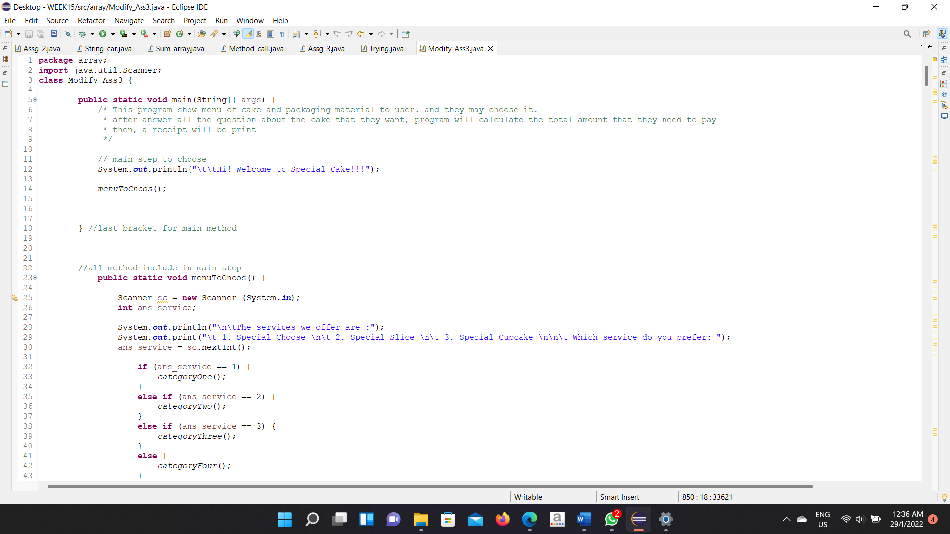**Coding Part**

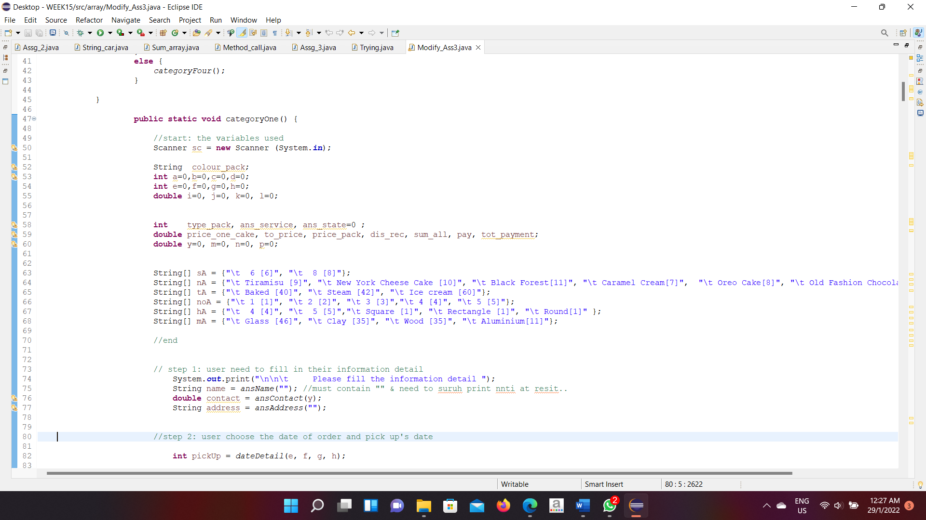

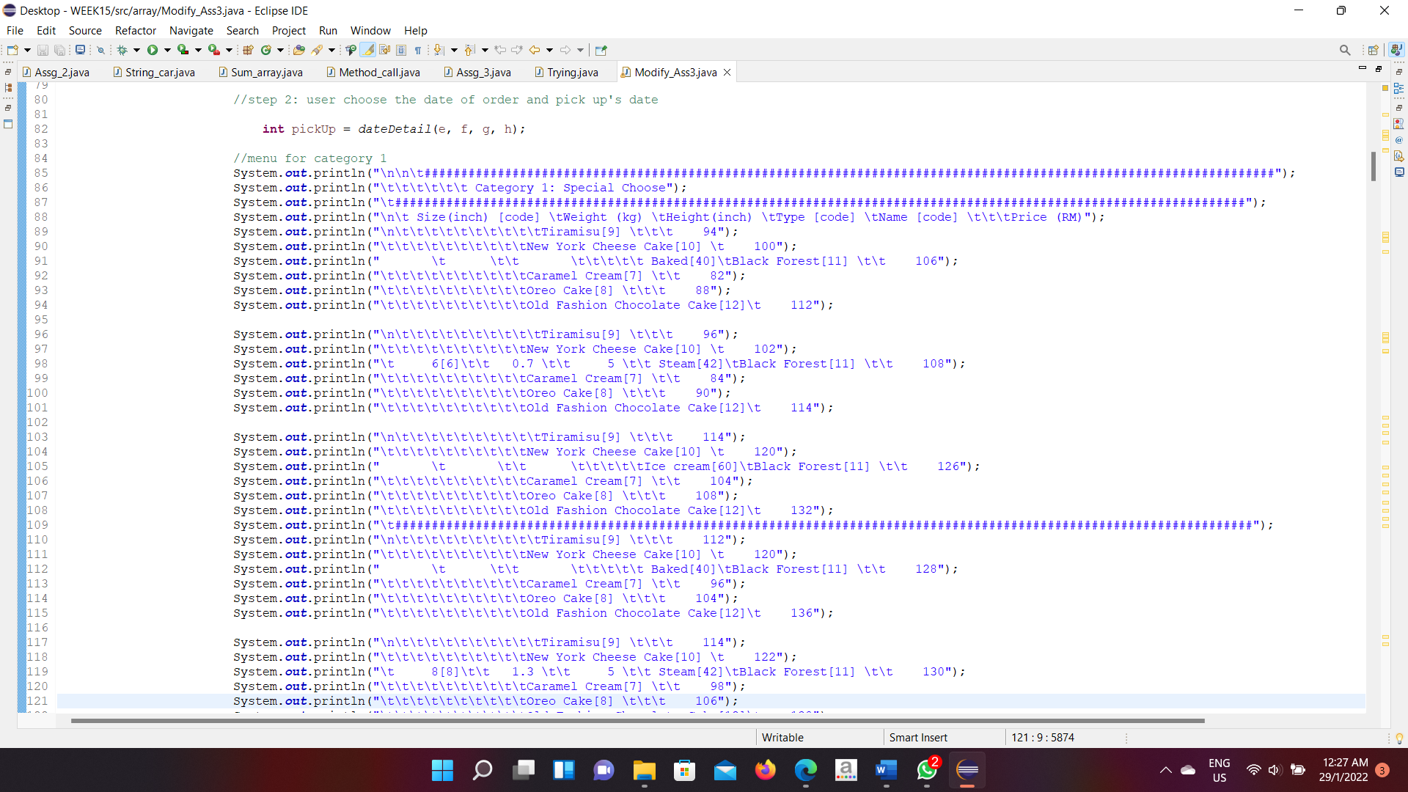

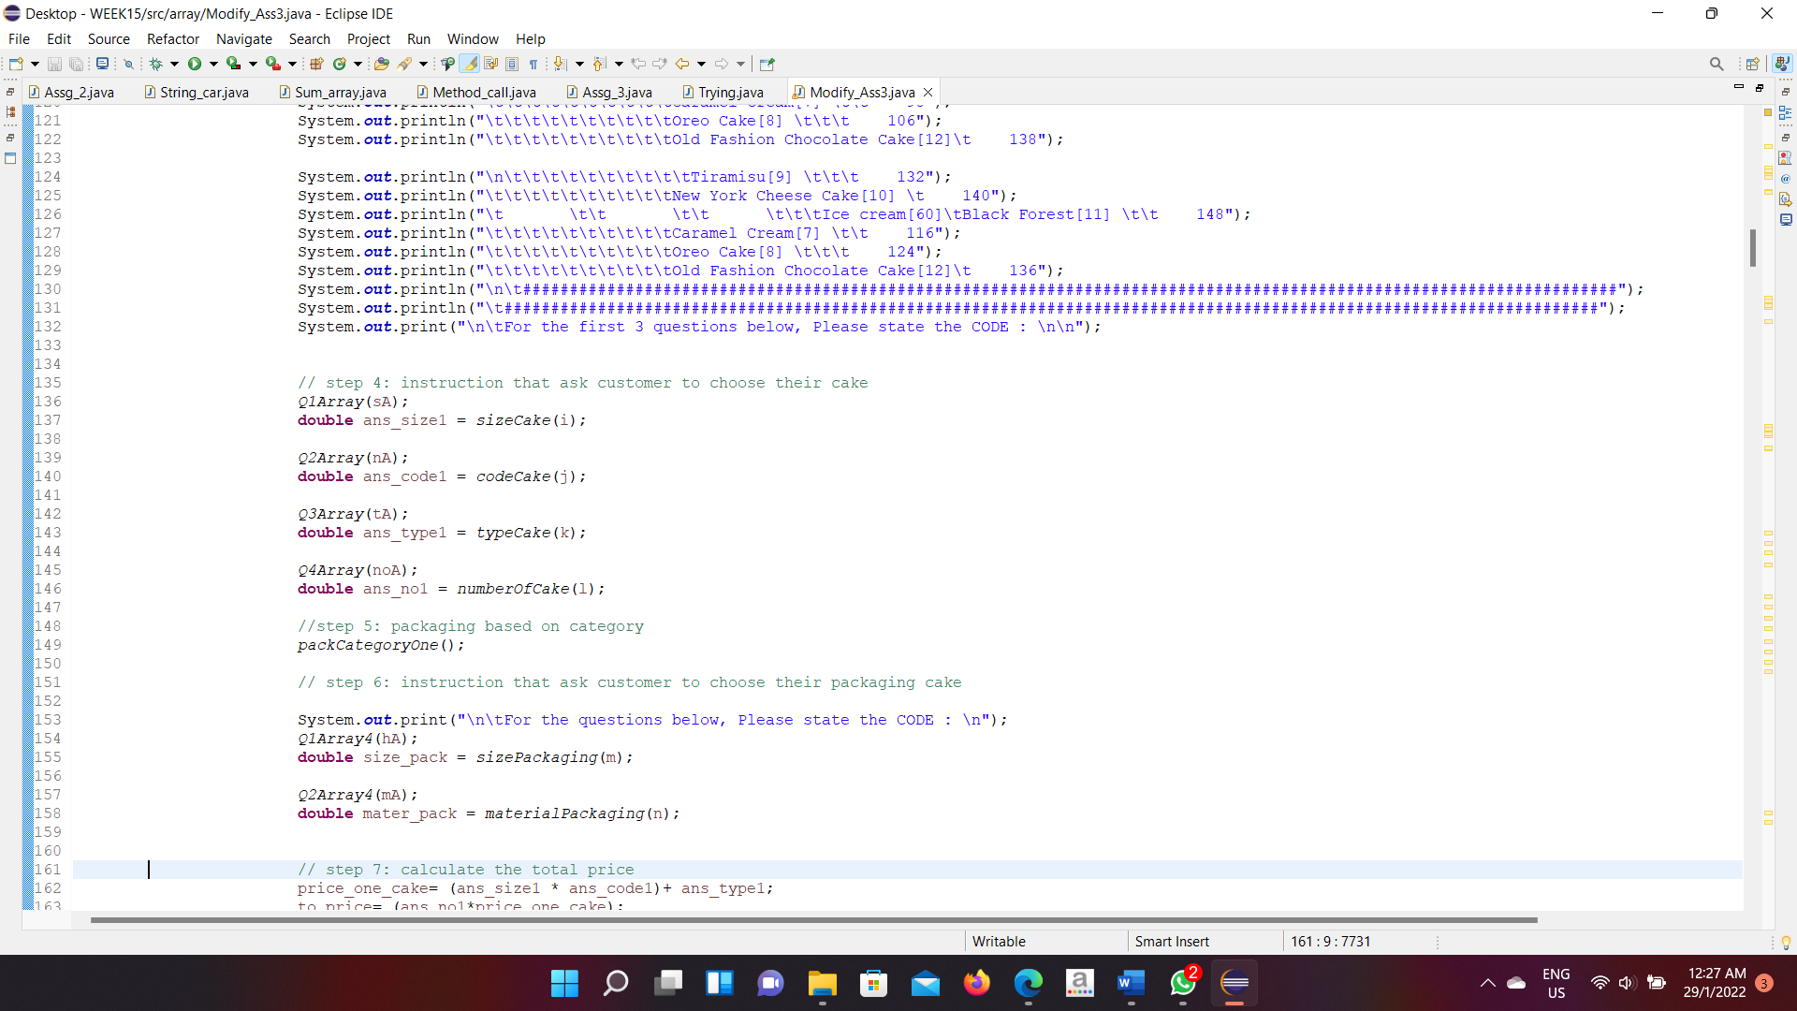

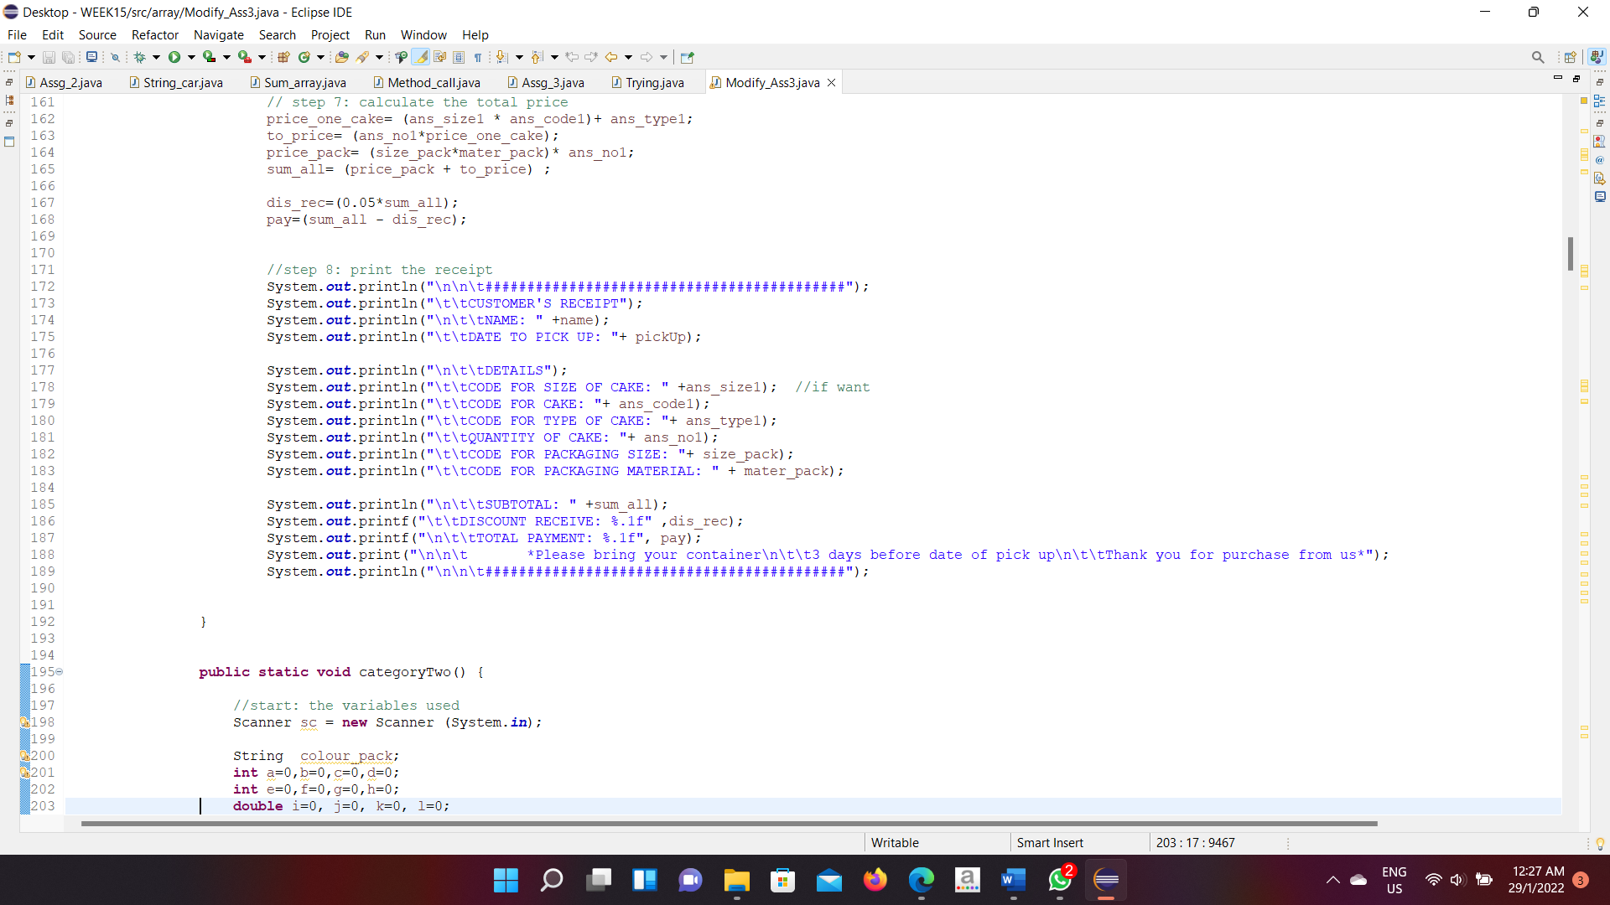

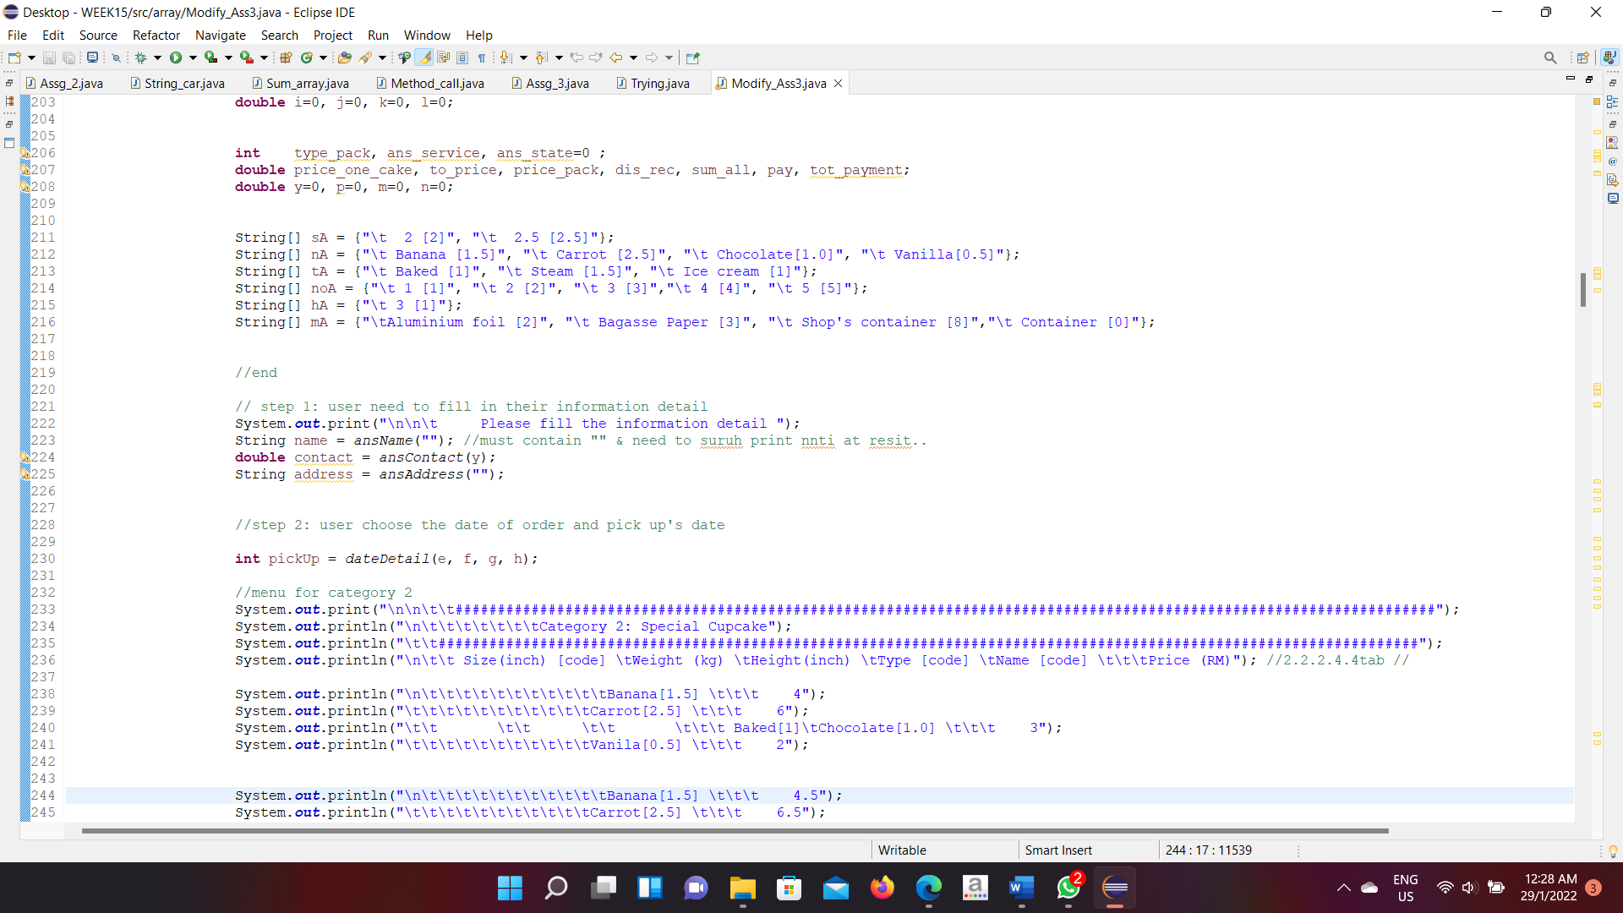

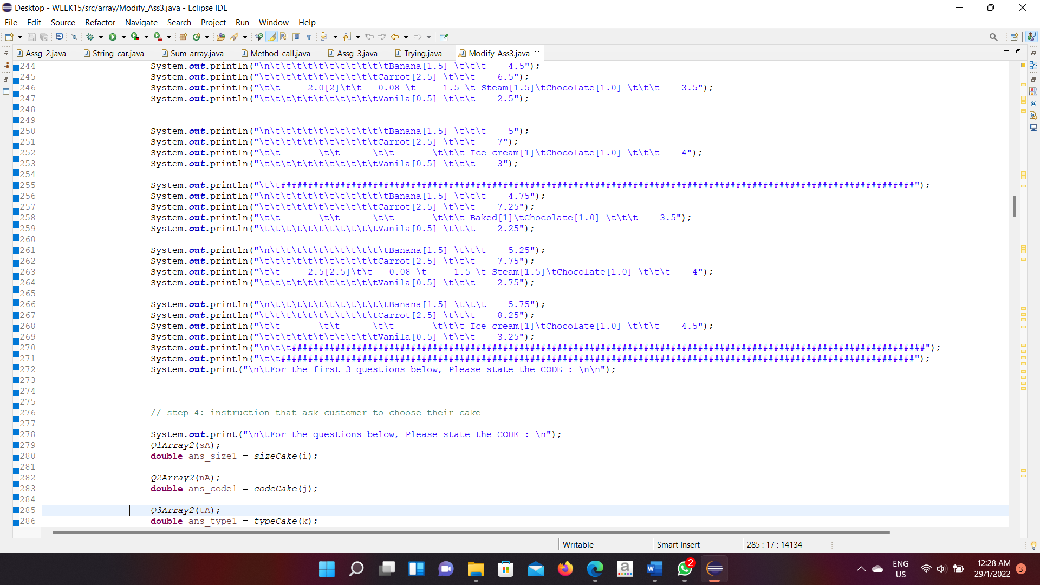

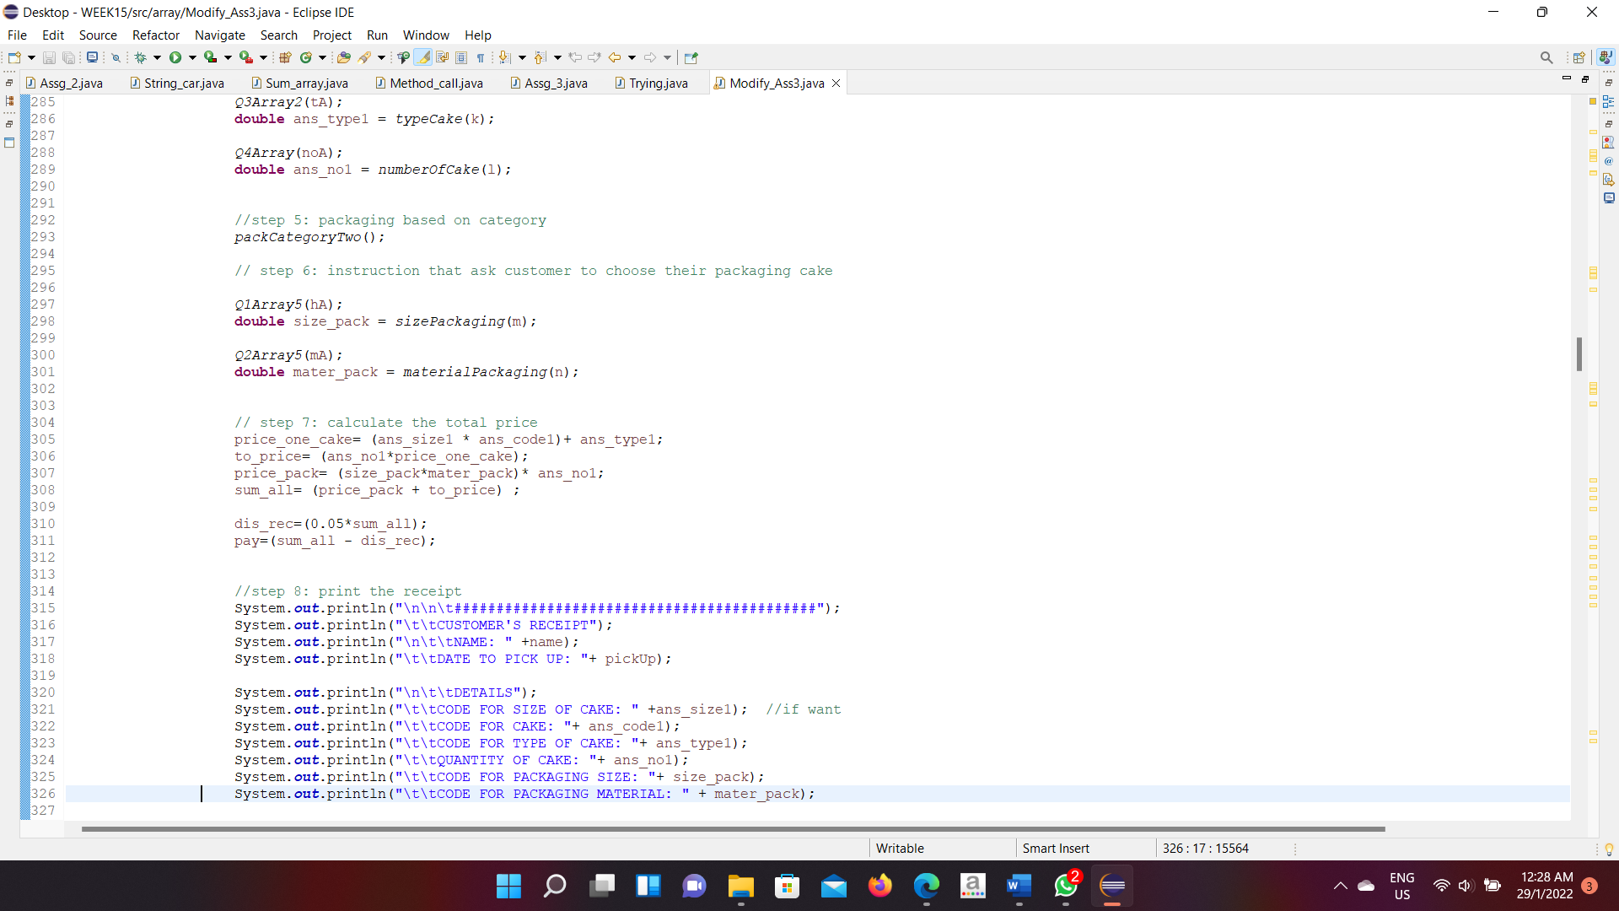

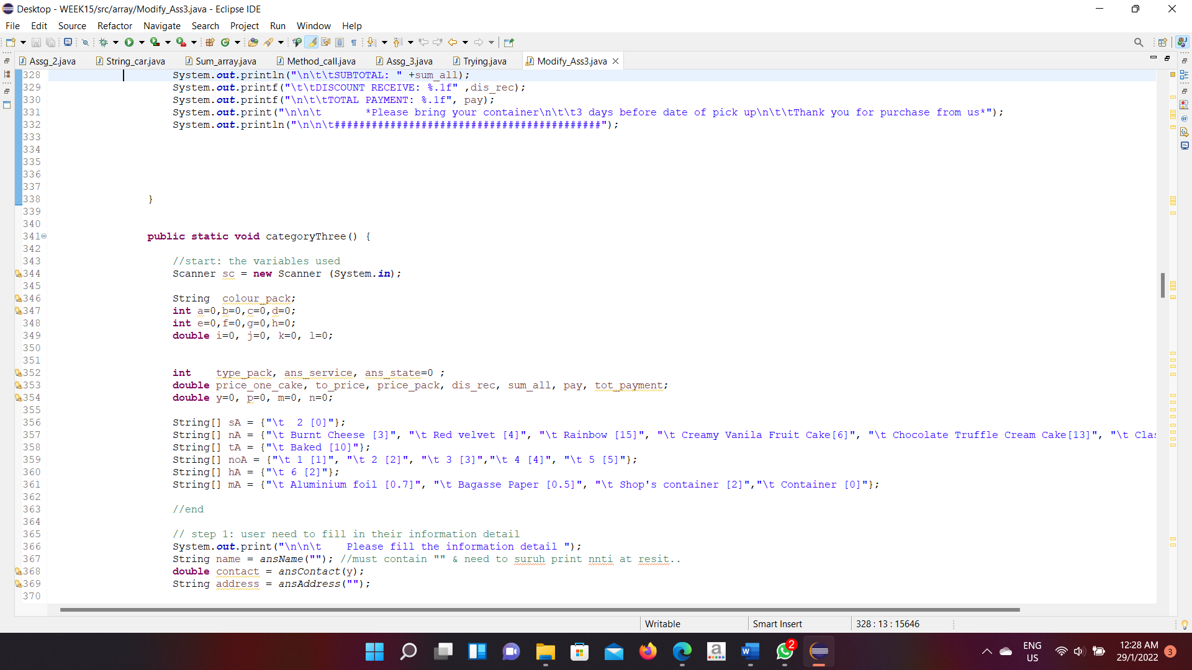

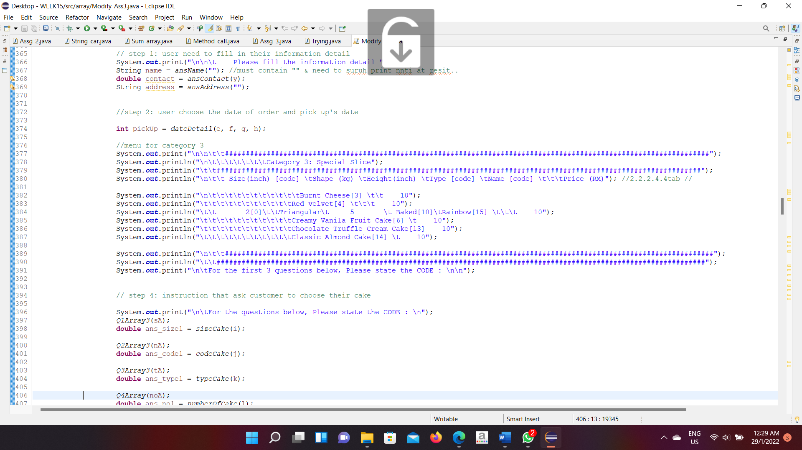

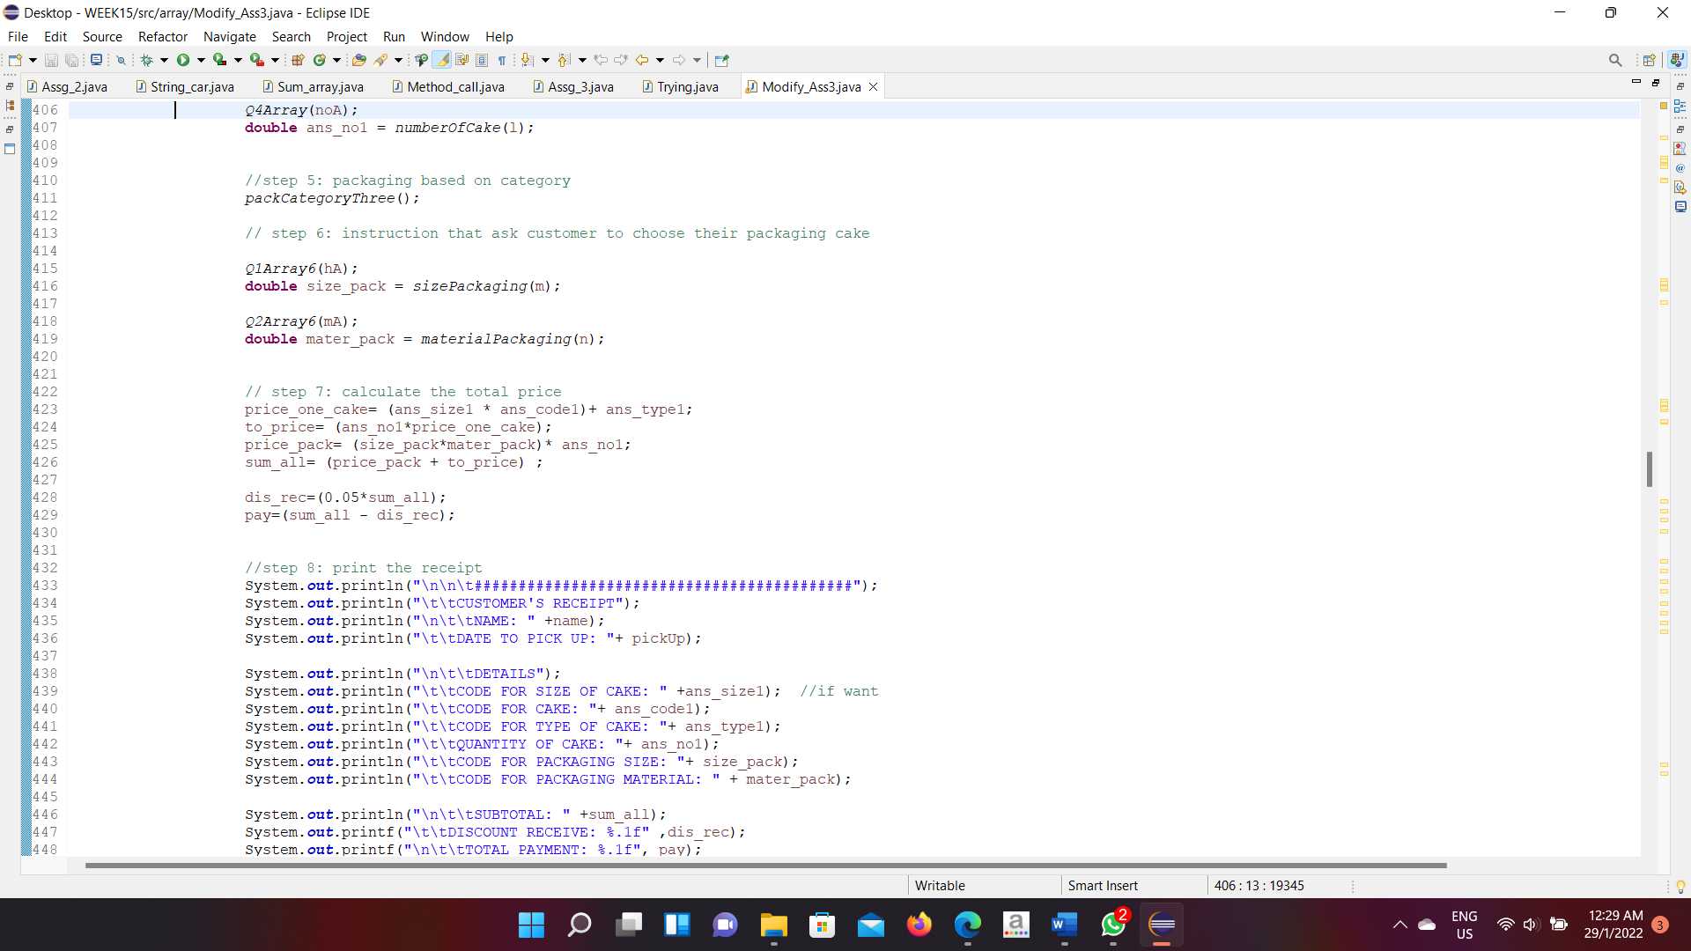

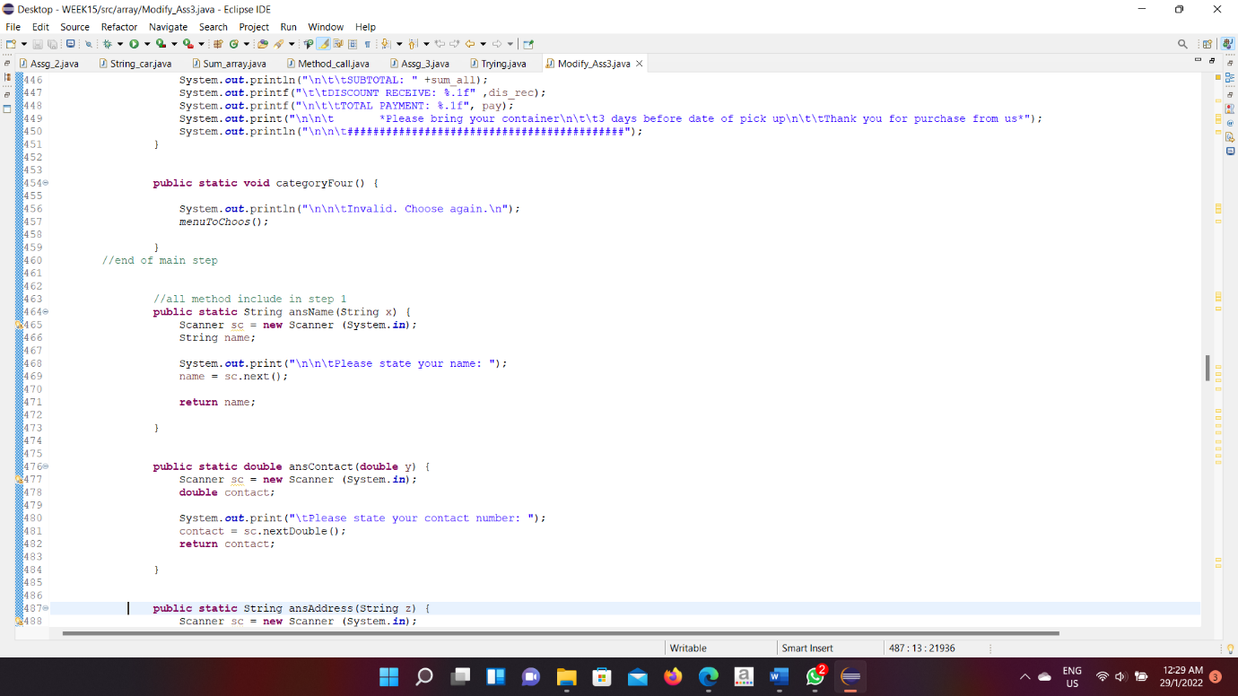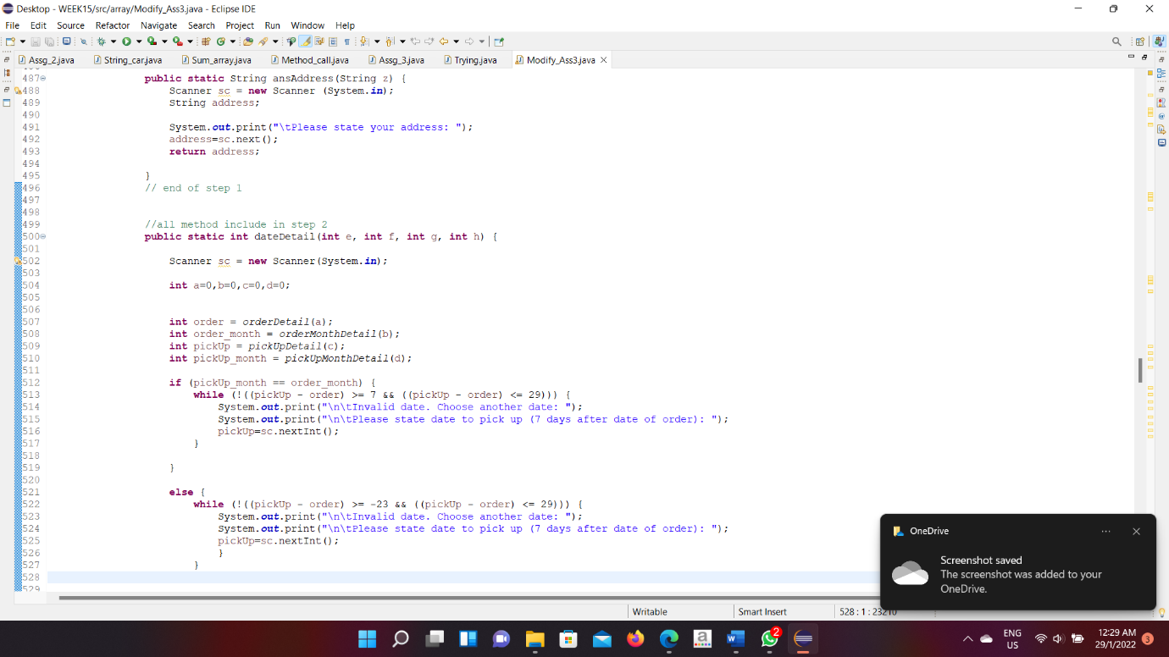

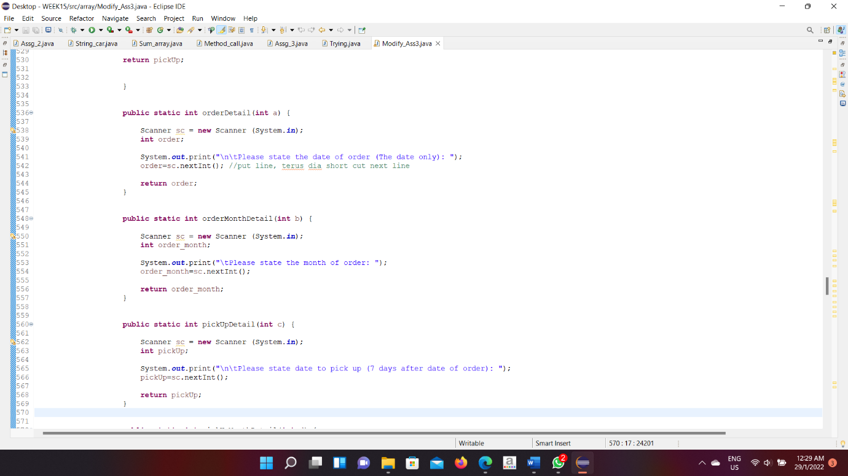

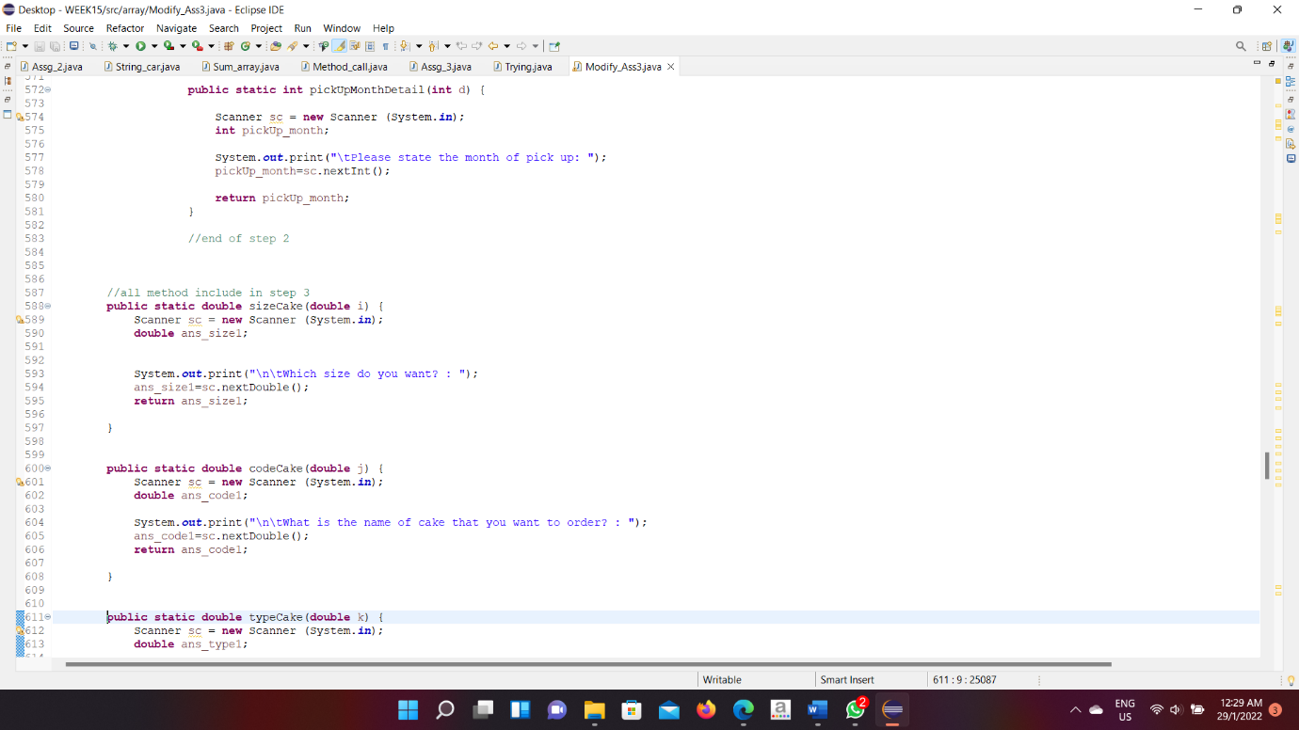

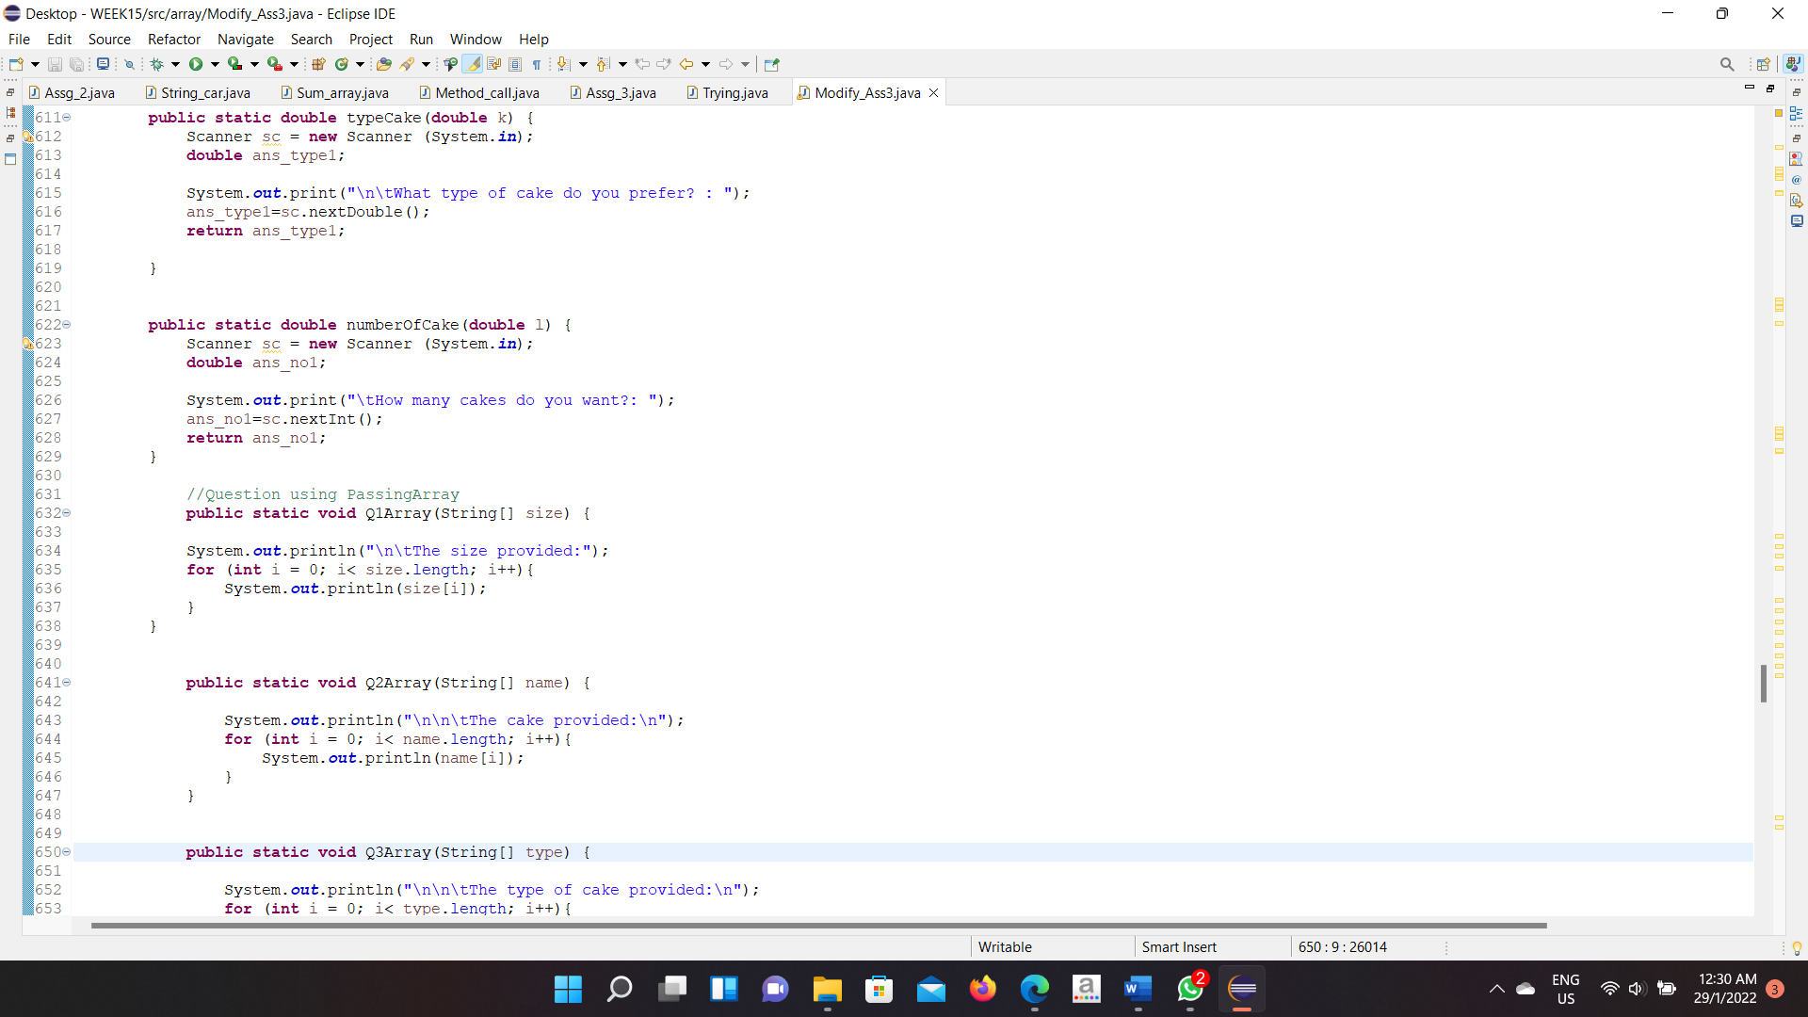

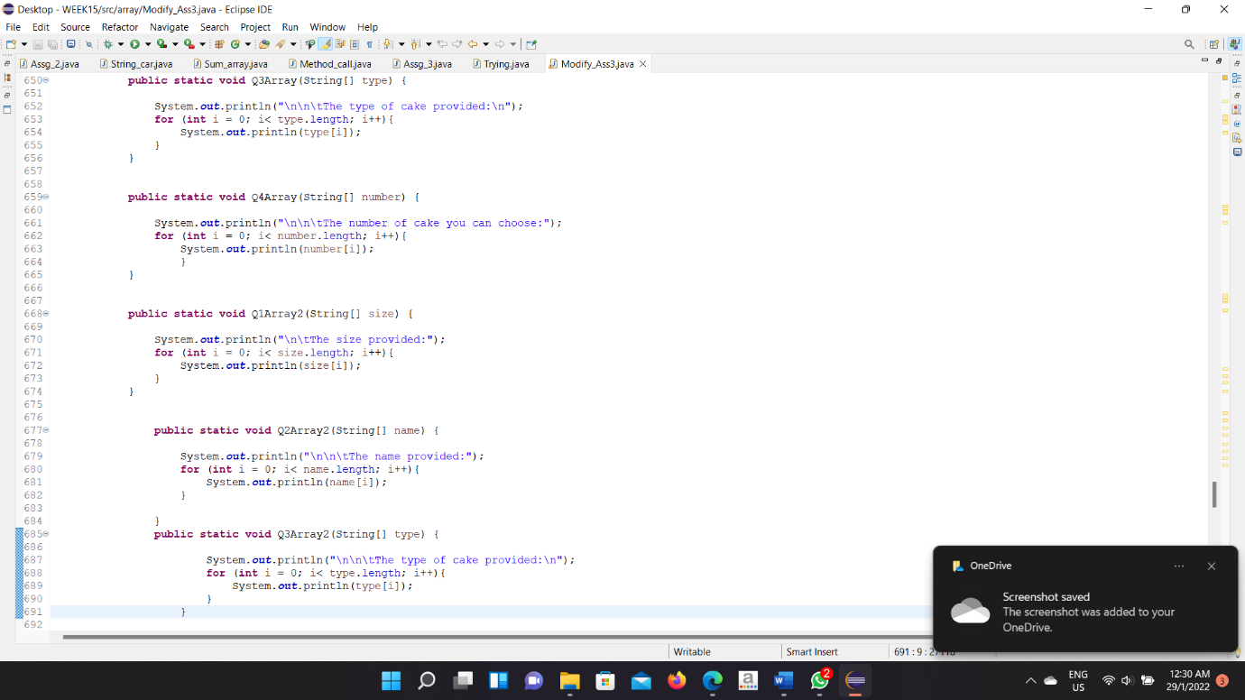

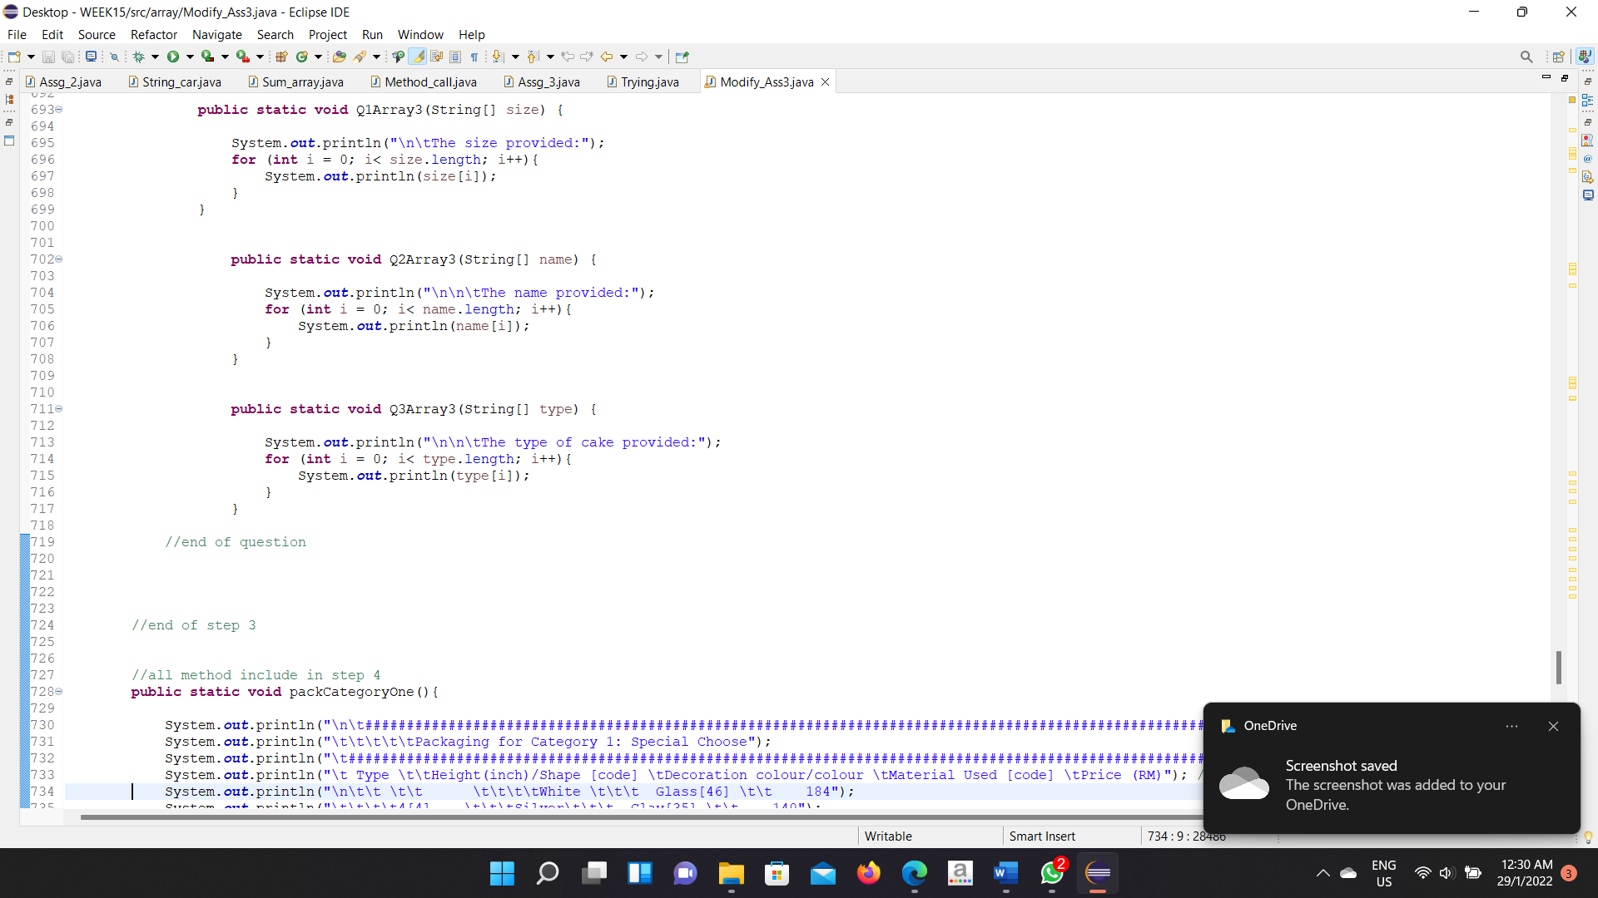

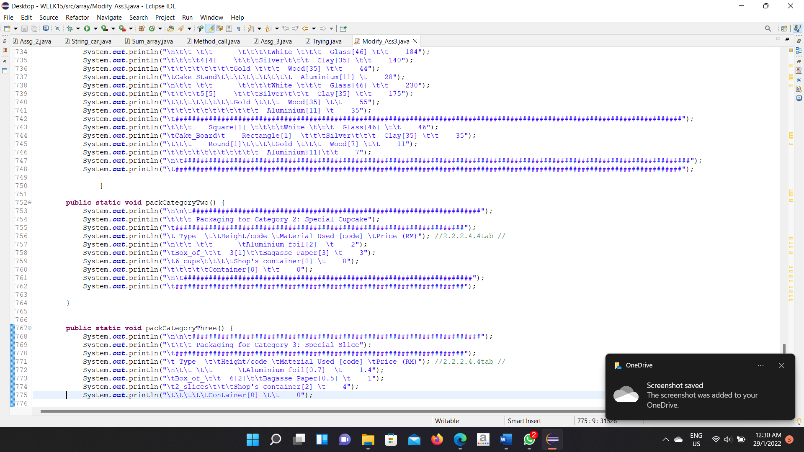

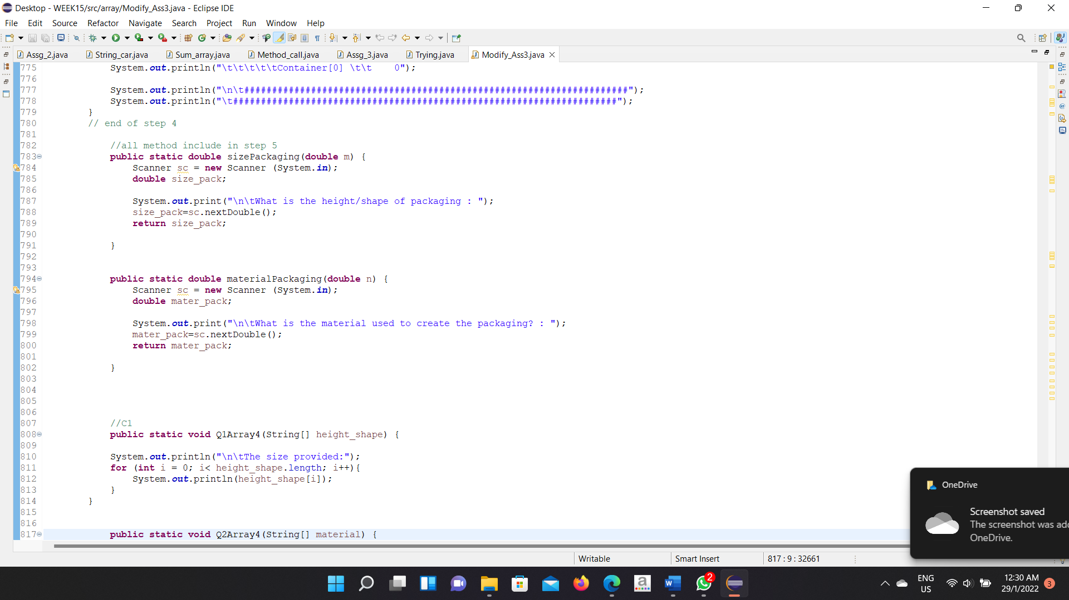

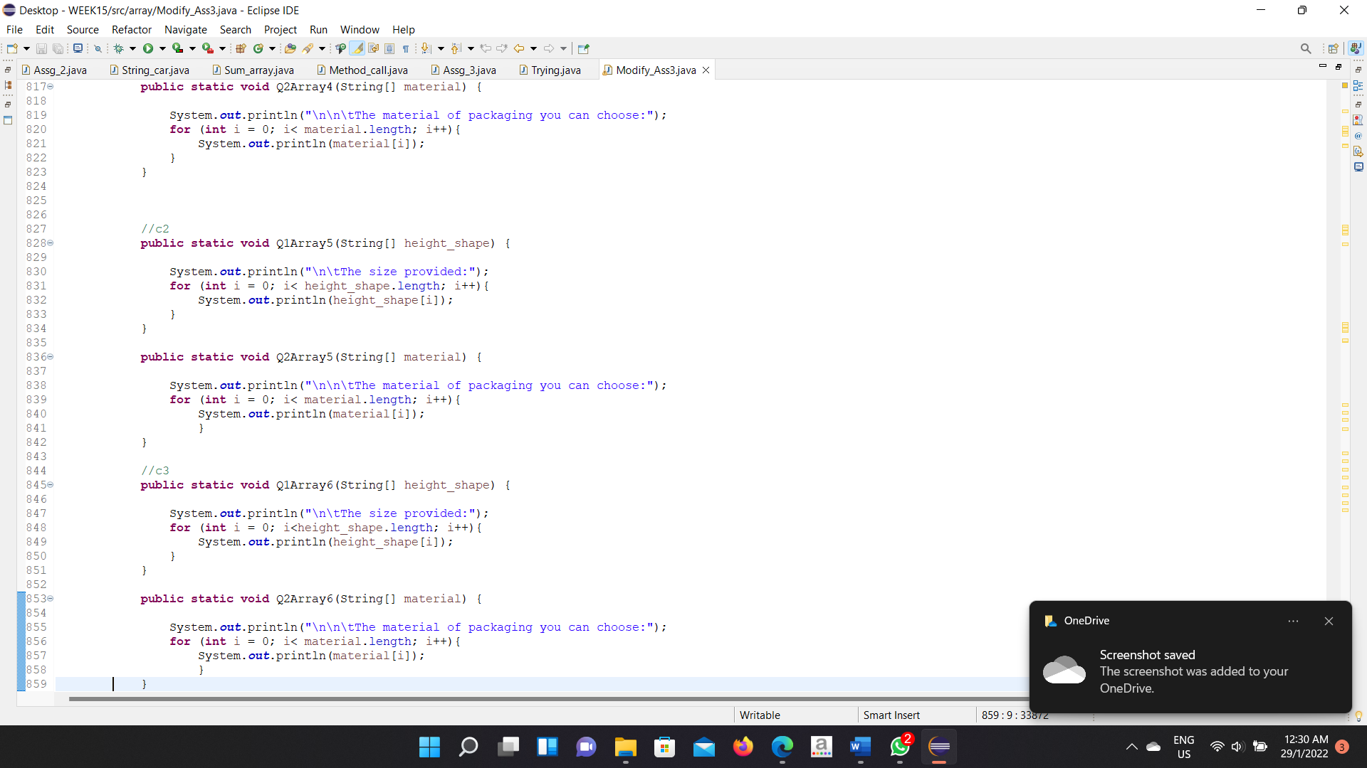

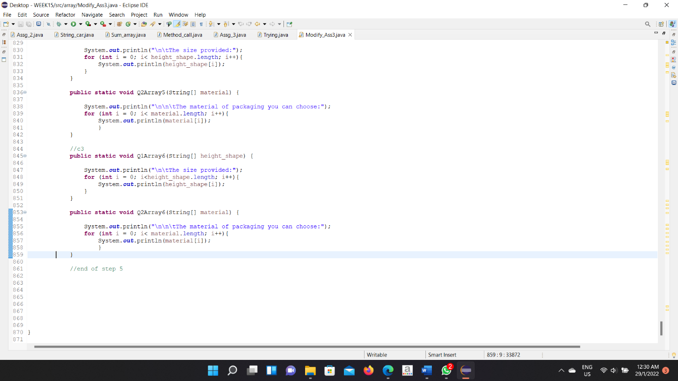

**Output Category 1**

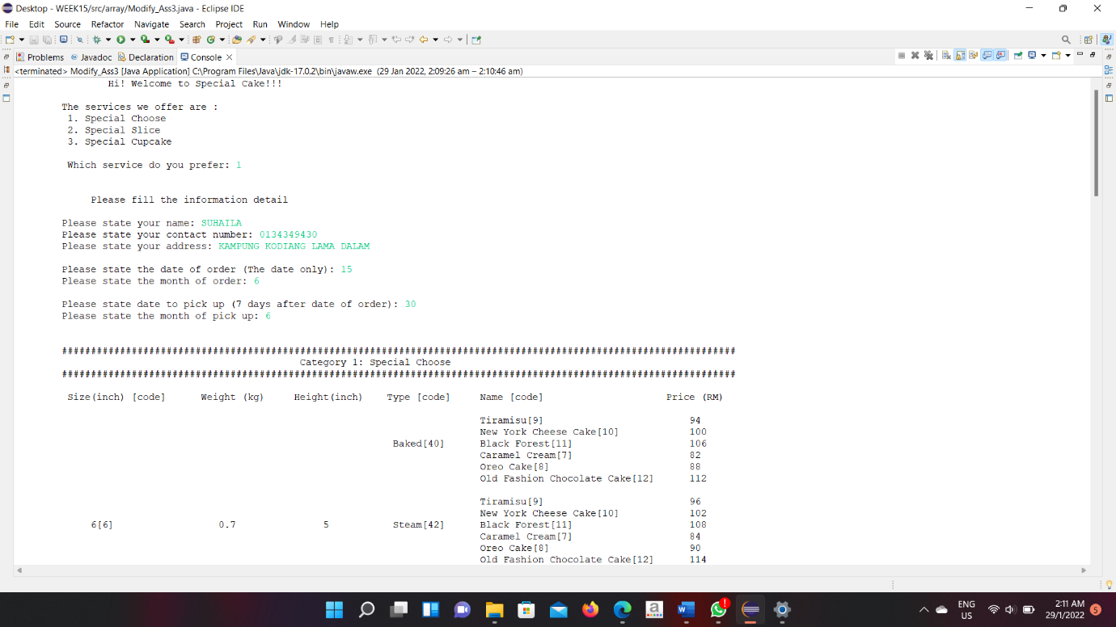

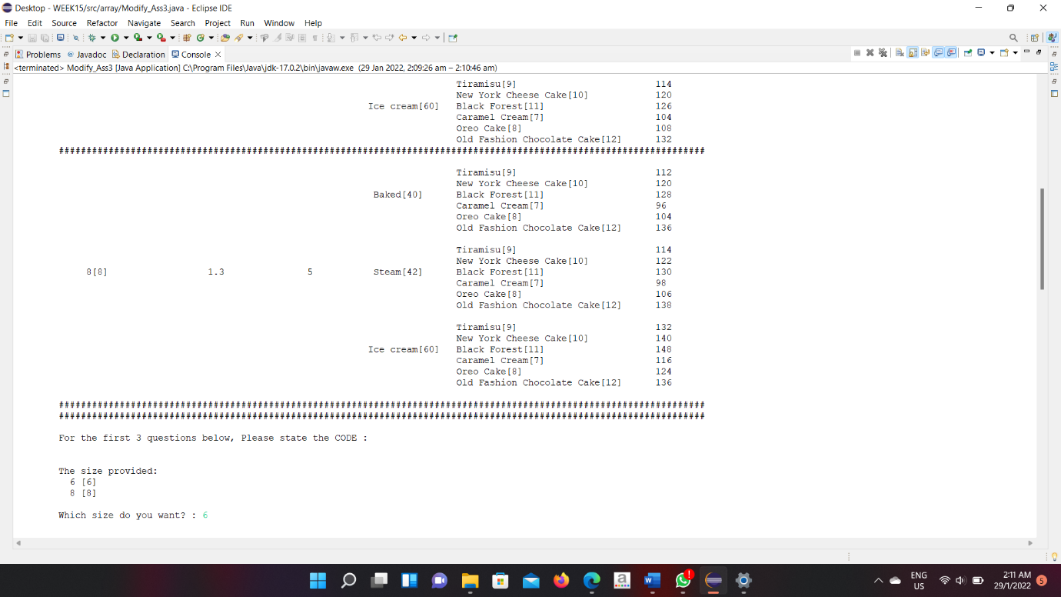

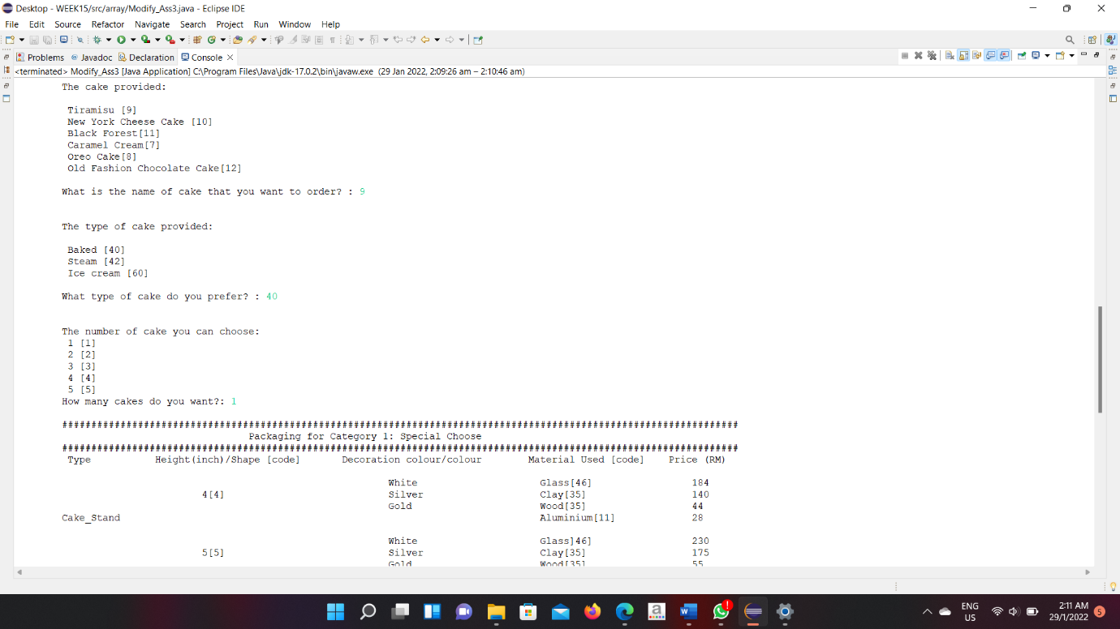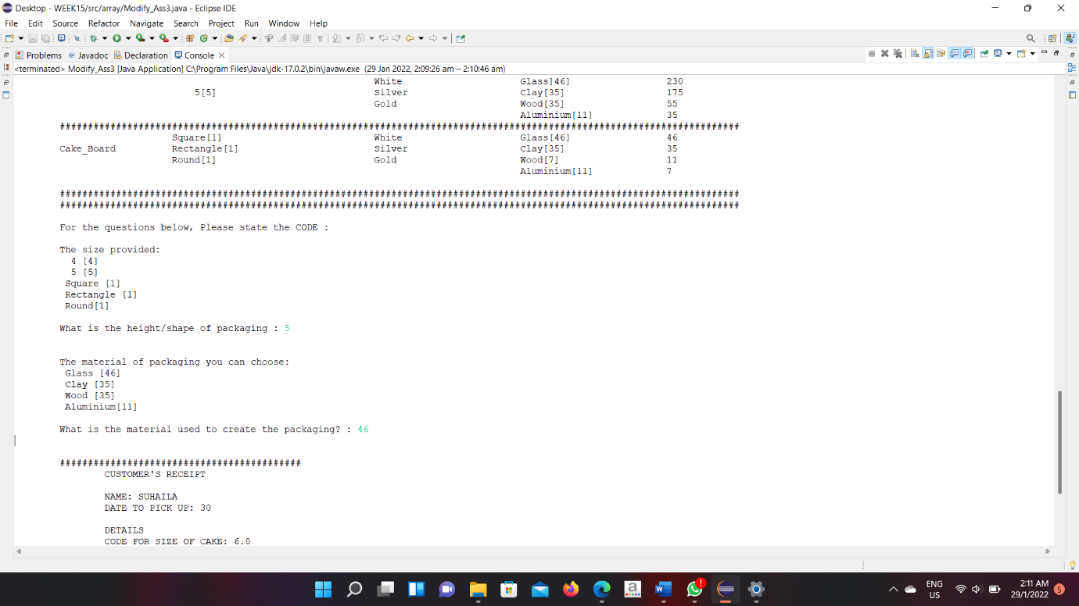

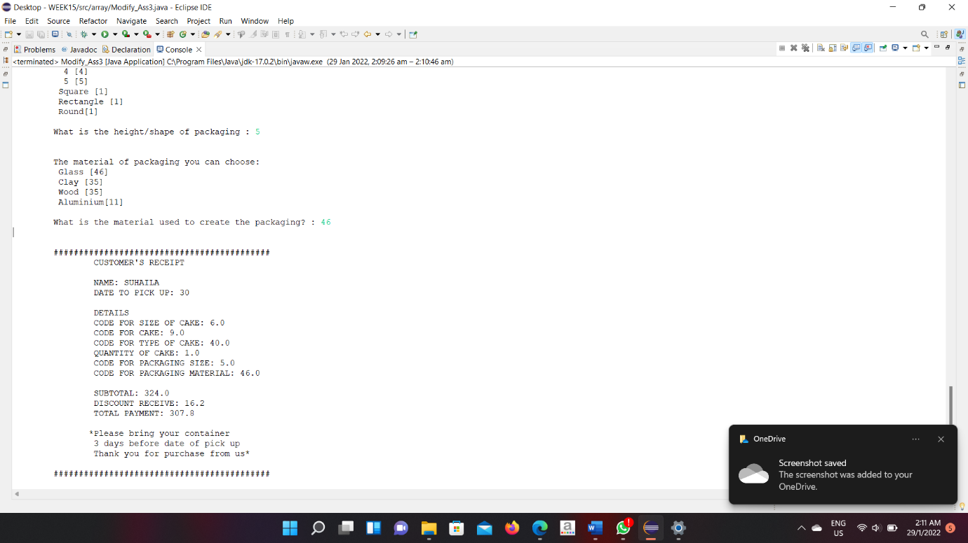

**Output Category 2**

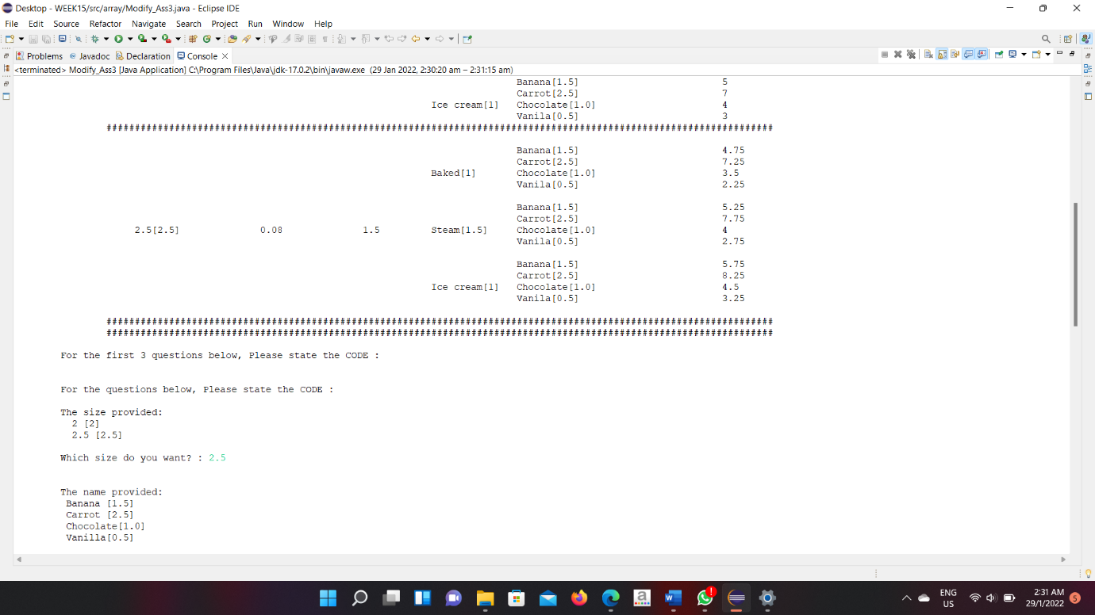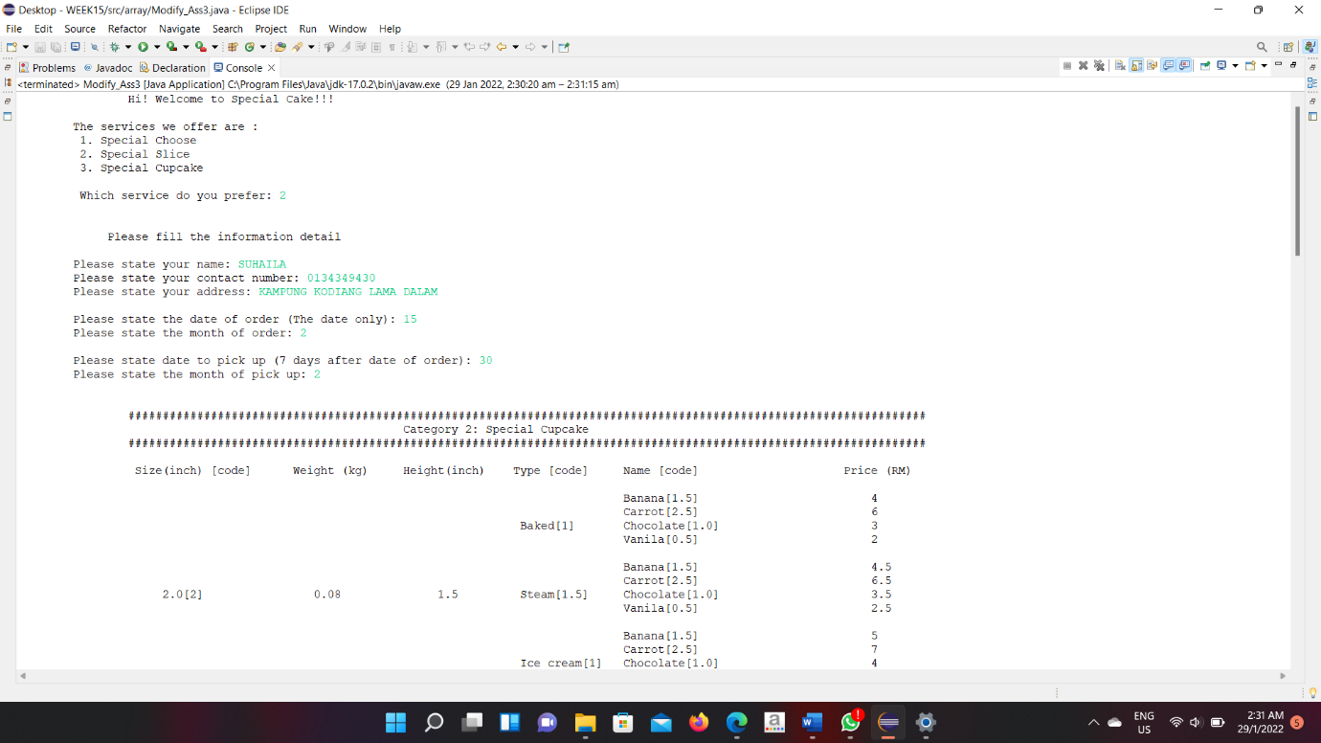

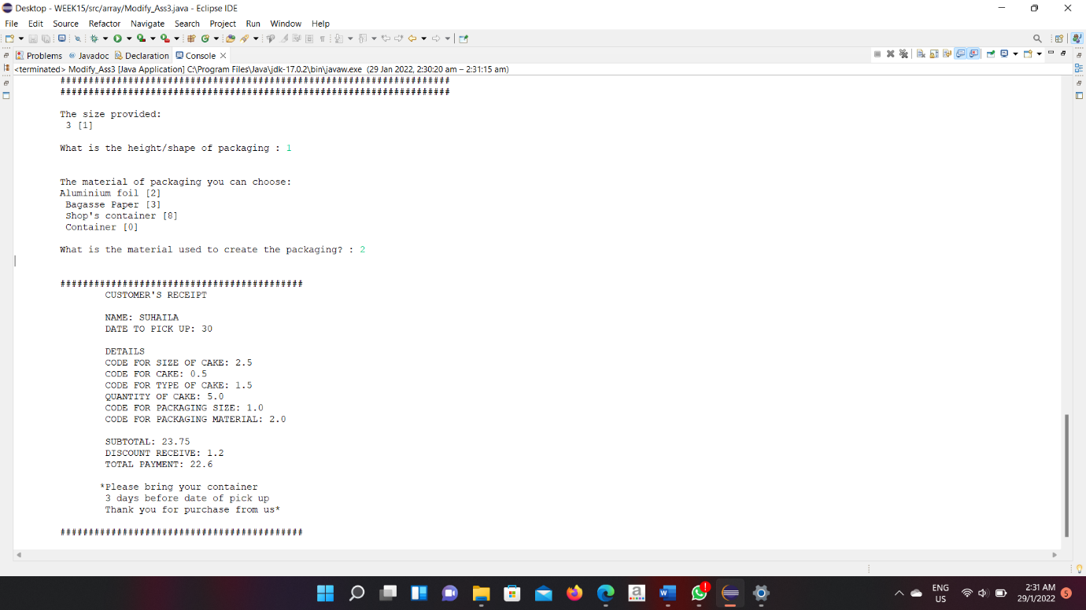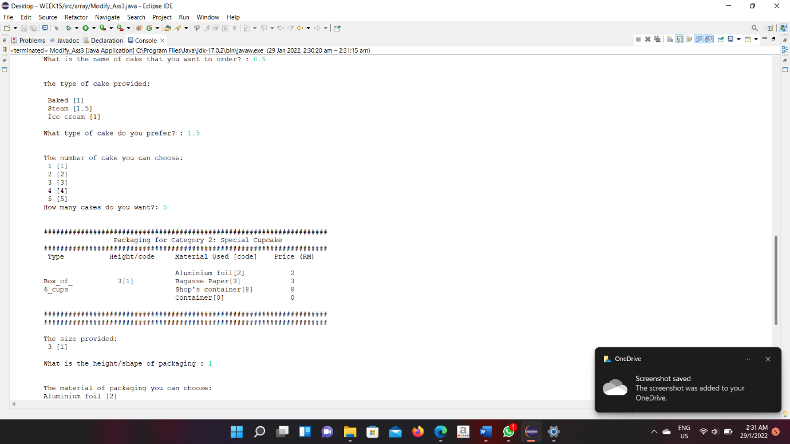

**Output Category 3**

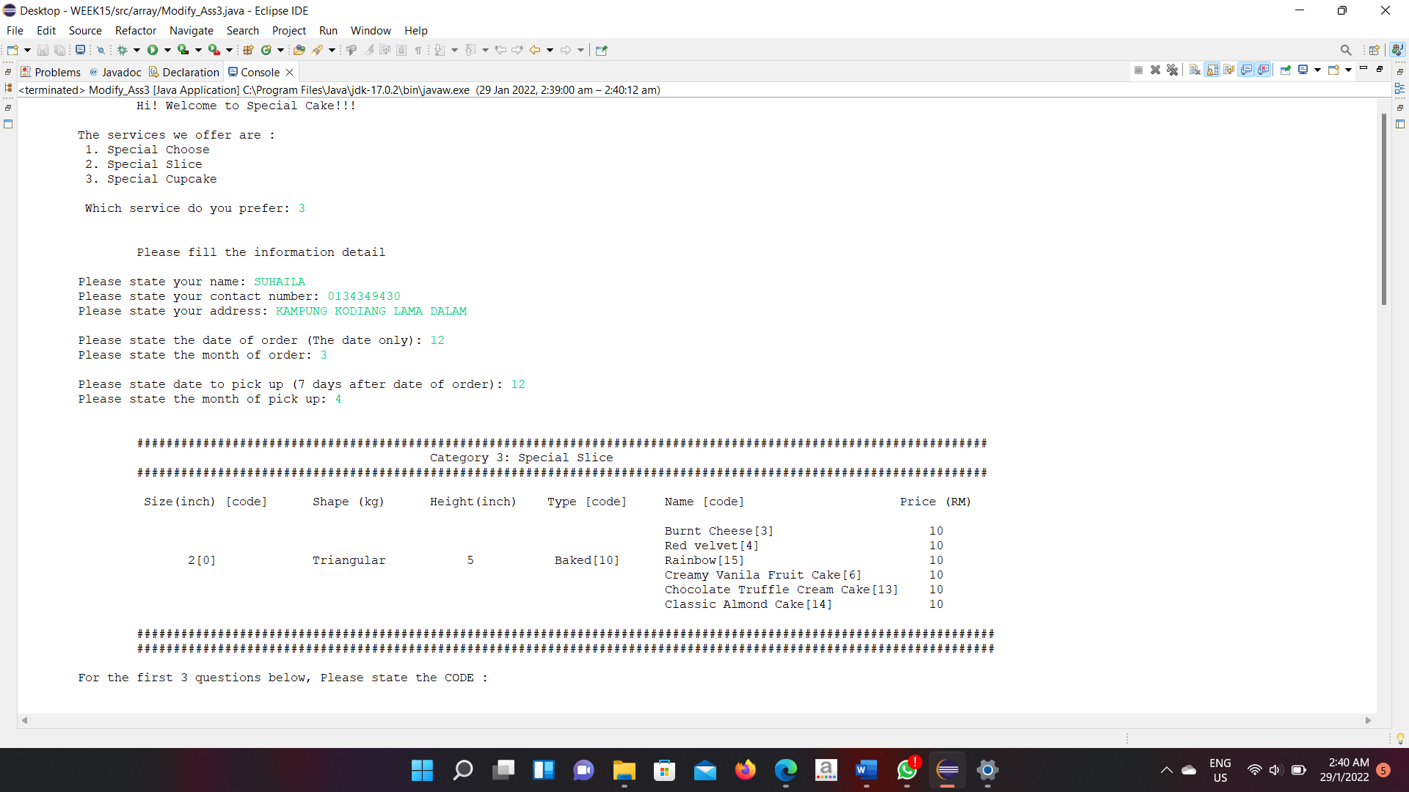

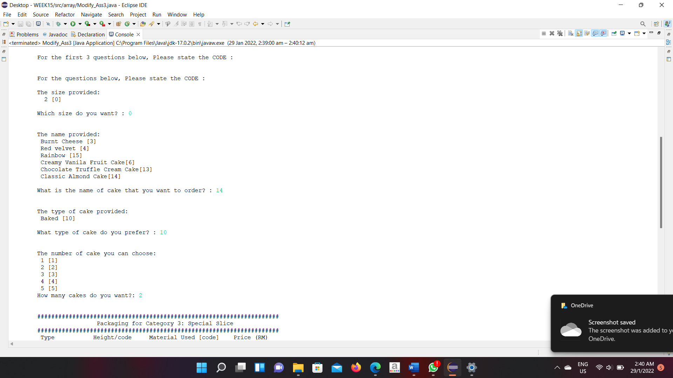

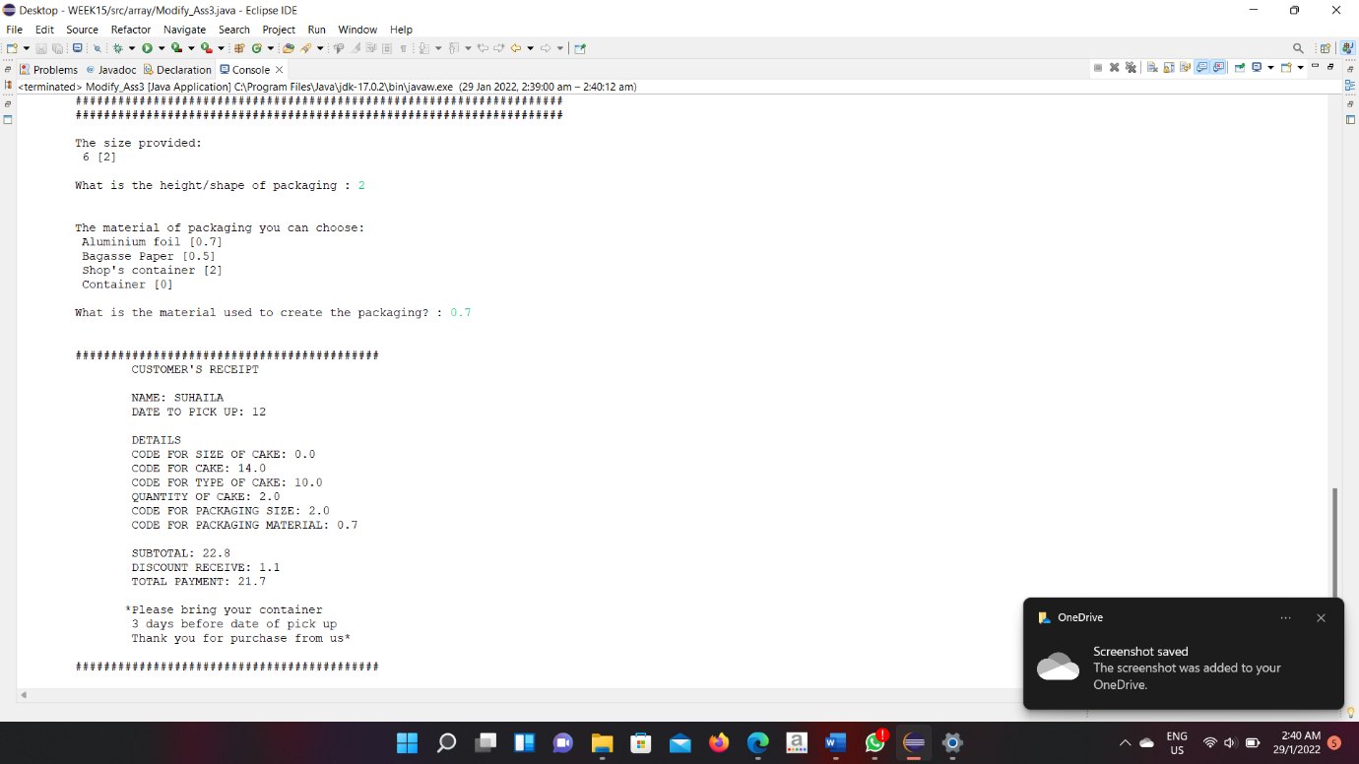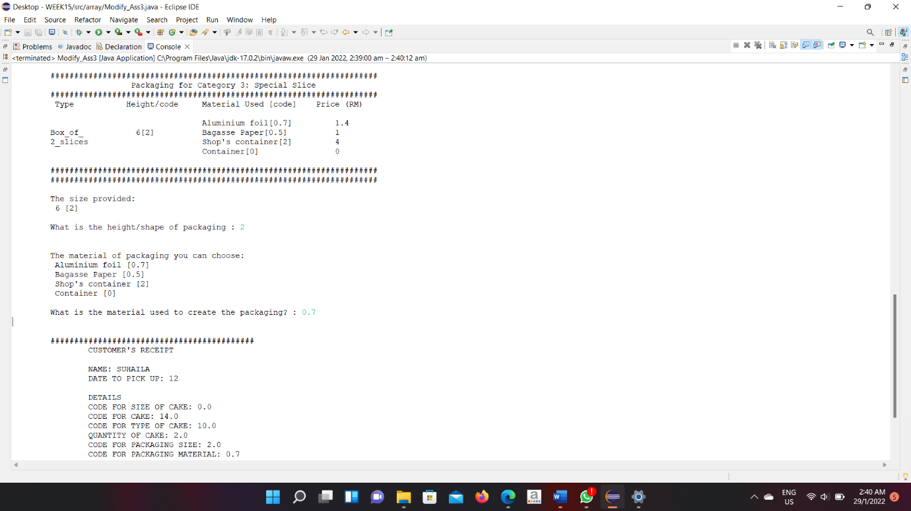

**REFERENCES**

ccorg41. (July 22, 2021). Eco-Anxiety: How Seeing A Therapist Can Help You Cope With Climate Change [Website URL]. Retrieved from <http://16icc.org/2018/11/27/the-> advantages-of-eco-friendly-products/

Osgood, A., McGringon, C., Pehws, J., Wright, J., Quinones, A., Guimaraes, I. and Olivia. (November 14, 2019). What is Eco-Friendly Packaging? (And Why It’s Important for Your Sales) [Website URL]. Retrieved from <https://www.rooland.com/what-is-eco-> friendly-packaging/

Apte, S. (January 30, 2019). 7 ADVANTAGES OF USING ECO-FRIENDLY PACKAGING [Website URL]. Retrieved from <https://www.smallbusinessbonfire.com/eco-friendly-packaging/>

Wikipedia. (November 19, 2021). Cake [Website URL]. Retrieved from <https://en.wikipedia.org/wiki/Cake>

Fincher, M. (August 20, 2020). 11 Different Types of Cake — and How to Tell Them Apart [Website URL]. Retrieved from <https://www.allrecipes.com/gallery/types-of-cakes/>

S, L. (January 20, 2013). The History of Cake & Facts You Didn't Know [Website URL]. Retrieved from <https://www.weekendnotes.com/history-of-cake-facts-you-didnt-> know/